**WATERSPORTS MANAGEMENT SYSTEM**

**A Project Report**

Submitted in partial fulfillment of the

Requirements for the award of the degree of

**BACHELOR OF SCIENCE (INFORMATION TECHNOLOGY)**

**By**

**Miss. Vishakha Santosh Terwankar**

**Seat Number**

**4027409**

**Under the esteemed guidance of**

**Asst. Prof. Mrs. P. N. Mishal**

**M.C.A.**



**DEPARTMENT OF INFORMATION TECHNOLOGY**

**VIJAYALAKSHMI VISHWANATH DALVIE COLLEGE TALERE**

***(UGC & Govt. of Maharashtra Funded Model College)***

**TALERE, TAL-KANKAVALI, DIST-SINDHUDURG, PIN-416801**

**MAHARASHTRA**

**2019-20**

**DECLARATION**

To,

The Coordinator,

Department of Information Technology,

Vijayalakshmi Vishwanath Dalvie College.

Respected Sir,

I undersigned, hereby declare that the project on **“WATERSPORTS MANAGEMENT SYSTEM” for Vijayalakshmi Vishwanath Dalvie College.”** is developed under the guidance of our lecturer Asst. Prof. Mrs. P.N. Mishal.

The conclusion in this report is based on the data, which is collected by me. I am declaring that this is my original work. I have not copied any materials, which are useful to my work, or other reports that are submitted to the VIJAYALAKSHMI VISHWANATH DALVIE COLLEGE this year.

I do undersign that if my work is found to be copied, then I am liable to punishment as per the university rule.

**DATE:**

**PLACE**: TALERE. (Miss. Vishakha Santosh Terwankar.)

**PROFORMA FOR THE APPROVAL PROJECT PROPOSAL**

PRN No : **2017016402461695** Roll no: IT6028

1. Name of the student

Miss. Vishakha Santosh Terwankar

1. Title of the project

Watersports Management System

1. Name of the Guide

Mrs. P. N. Mishal

1. Teaching experience of the Guide

4 yrs.

1. Is this your first submission? Yes No

Signature of the Student Signature of the Guide

Date: …………………. Date: ……………………

Signature of the Coordinator

Date: ……………………

**VIJAYALAKSHMI VISHWANATH DALVIE COLLEGE TALERE**

***(UGC & Govt. of Maharashtra Funded Model College)***

**TALERE, TAL-KANKAVALI, DIST-SINDHUDURG, PIN-416801**

**DEPARTMENT OF INFORMATION TECHNOLOGY**



**CERTIFICATE**

This is to certify that the project entitled, **“Watersports Management System”**, is bonafied work of **Miss. Vishakha Santosh Terwankar** bearing Seat. No: **4027409** submitted in partial fulfilment of the requirements for the award of degree of **BACHELOR OF SCIENCE** in **INFORMATION TECHNOLOGY** from University of Mumbai.

**Internal Guide Coordinator**

**External Examiner**

**Date: College Seal**

**Role and Responsibility**

* **Requirement Gathering:**

The software development team work to carry on the project. The team discussion can solve the various problem of the project and tries to bring out as much information as possible from the requirement.

The requirements are collected using a number of practices as given absolute system.

* **System Analysis:**

Requirements analysis is done in order to understand the problem, which is to be solved. That is very important activity for the development of database system. The requirements and the collection analysis phase produce both data requirements and functional requirements. The data requirements are used as a source of database design. The data requirements should be specified in as detailed and complete form as possible.

Understanding of software limitation, system related problems or changes, Identifying the impact of project on the organization.

* **Database Administrators (DBA):**

Design and create a database and tables for the project. Define schema and field of the project etc.

* **Software Design:**

After gathering information and analysis we moved on the design phase. Actual designing means making various form related about our system or software.

* **Coding:**

This phase is also known as programming phase. After the designing phase we move to coding phase implementing a software design starts in terms of writing program code in the suitable programming language. Develop actual module of the solution include coding, and database, connectivity, interface etc.

* **Testing**:

An estimate says that 50% of whole software development process should be tested. In test phase error may ruin the form software. Software is done while coding by the developers and then testing through the experts. It tests a project meet the general requirement of the watersports management system and it is error free and defeats. It also includes validator and test cases and also different types of test methodologies.

* **Integration:**

Software may need to be integrated with the libraries, database and other programs.

* **Implementation:**

Actual delivery of the project to the watersports management system for the working and enhance functionality of the watersports management system. Implementation of the software in user machine.

* **Maintenance:**

After developing and testing the software deployment team deploys the software at the client side. This is process which done after releasing the software.

If any problem occurred in the software so maintain team will resolve the problem regarding the software. Finally, the software is handed over to the clients to be installed on their devices.

**Responsibilities:**

1. Planning and defining scope of the project.
2. Activity planning and sequencing.
3. Resource planning.
4. Feasibility study.
5. Developing Schedule.
6. Cost Estimation.
7. Developing Budget.
8. Creating figure, Charts, Schedule, and Database Etc.
9. Risk Analysis.
10. Monitoring and Reporting the progress to the Guide.
11. Overall Requirement Analyst, Designer, Coder, Tester, Deployment of Project and others.

**Abstract**

In nowadays people from all age like to do watersports at least once in life. To do watersports in life they have to visit the nearby watersports.

When people visit water sports, they need to provide information of water sports in details. When they book ticket, they need to know about water sports, how many rides are there and know about the price of those water sports in details.

The project is aimed at developing an application for **“Watersports Management System”.**  In this project all the paper work is .maintained in a single system. This module can use in water sports to enter customer details and for generating ticket to them.

The watersports management system gives the details of the watersports to the customer. When customer book more than 3 watersports, he will get discount. It provides all the information like about rides, price, and the number of members. The system will also display discount amount on the receipt and at each time it will generate report.

**ACKNOWLEDGEMENT**

I have taken efforts in this project. However, it would not have been possible without the kind support and help of many individuals and organizations. I would like to extend my sincere thanks to all of them.

I am highly indebted to Ass. Prof. Mrs. P. N. Mishal, Asst. Prof. Ms. R. A. Munagekar, Asst. Prof. Mrs. G. S. Lad, Asst. Prof. Mrs. S. V. Jadhav, Asst. Prof. Mr. A. S. Samat for their guidance and constant supervision as well as providing necessary information regarding the project and also for their support in completing the project.

I would like to express my gratitude towards my parents & member of **Vijayalakshmi Vishwanath Dalvie College** for their kind co-operation and encouragement which help me in completion of this project.

I would like to express my special gratitude and thanks to industry persons for giving me such attention and time.

My thanks and appreciations also go to my colleague in developing the project and people who have willingly helped me out with their abilities.

**Table of Content**

|  |  |  |  |
| --- | --- | --- | --- |
| **Sr. No.** | **Chapter No.** | **Title** | **Page No.** |
| **1.** | **I** | **Introduction**   * 1. Background   2. Objective   3. Purpose, Scope & Applicability   4. Achievements. |  |
| **2.** | **II** | **Survey Of Technologies** |  |
| **3.** | **III** | **Requirement Analysis**   * 1. Problem Definition   2. Requirement Specification   3. Feasibility Study   4. Planning and Scheduling   5. Software and Hardware Requirements   6. Preliminary Product Description   7. Conceptual Models |  |
| **4.** | **IV** | **System Design**   * 1. Basic module.   2. Data Design      1. Schema Design      2. Data Integrity and Constraints   3. Procedural Design      1. Logic Diagrams      2. Data Structures   4. Algorithm Design   5. User Interface Design   6. Security Issue.   7. Future Enhancement.   8. Test Cases Design. |  |
| **5.** | **V** | **Implementation & Testing**  1.Testing |  |
| **6.** | **VI** | **Result & Discussion**  1.Reports |  |
| **7.** | **VII** | **Conclusion & References**  1.Conclusion  2.References |  |

**Table of Figure**

|  |  |
| --- | --- |
| **Title** | **Page No.** |
| 1. System flow chart 2. Entity Relationship Diagram 3. Class Diagram 4. Object Diagram 5. Package Diagram 6. Component Diagram 7. Deployment Diagram 8. Use Case Diagram 9. Sequence Diagram 10. State Transition Diagram 11. Activity Diagram |  |

**CHAPTER- I**

**INTRODUCTION**

**Background**

**Organizational Overview:**

**Project Name:**

Watersports Management System

**Objective:**

To make attractive software for overcome workload

**Location:**

At Post- Achara Tal- Malvan, Dist.- Sindhudurg

**Pin:**  416626

**Phone no.:** 9168047280

**Establishment:**

2019 (TVS Watersports)

**Affiliation:**

U.G.C & Govt. Maharashtra Funded University of Mumbai’s Model College

**About Project:**

To develop an effective system this is fast accurate, consistent, reliable and flexible enough so that it can accommodate any further expansion.

**Coordinator of the college:**

Dr. A. S. Kulkarni (Co-ordinator, V.V. Dalvie College, Talere.)

**Objectives**

Objective of my project is to make the current manual system into computerized will be more effective to use.

**The Project Objectives are:**

* Watersports management system is to develop software which create the ticket/receipt to the customer.
* Watersports Management system gives the watersport’s details.
* The system also gives the ticket’s details like category name, ride name, duration and amount.

**Purpose, Scope & Applicability**

**Purpose:**

The manual work of creating ticket and giving it to customer is slow process. The manual work to giving details of each watersport is time consuming. For creating ticket manually, all the paperwork makes it slow. To avoid this problem, “Watersports Management System” proposed.

It maintains all the records of the Watersports. The admin can easily access and update the data with the help of login id.

Our project provides the facilities like maintain all the records of customer and maintain the details of watersports and create ticket for the customer.

**Scope:**

This system can store the customer’s details for the ride. Only the admin and employee has the authority to maintain the details of the customer. Admin takes the customer’s ticket booking details and make ticket for the customer. Only the admin can access the data of the customer. The watersports details are given in the ticket. Admin have to right for update details about sports, income & view details of daily sports/rides which is done by customer. After each booking reort will be updated.

**Applicability:**

The project “Watersports Management System” is applicable for the different types of watersports management. The admin gathered the information of the customer and print the ticket.

**Achievements**

**Proposed** **System**: - Watersports Management System

Some of the achievement of the projects is as follows

1. New and attractive application will fulfill the requirement.
2. No manual work is required
3. Record keeping becomes easy
4. No paperwork is required
5. Easy to find out information of any customer
6. Easy to update the information of customer or employee.
7. Updating information is easy.

**Organization of Report**

Chapter 1 to 7 (Introduction, Survey of Technologies, Requirement & Analysis, System Design, Implementation & Testing, Result & Discussion, References & Conclusion) covered in this documentation. The following chapter is to be included:

**Chapter 1: Introduction**

In the first chapter, describe the introduction of project. That can include background, objective, purpose, scope, applicability of the project.

**Chapter 2: Survey of Technologies**

In this chapter survey of technologies should demonstrate the awareness and understanding of available technologies related to the topic of the project.

**Chapter 3: Requirement and Analysis**

In this chapter define the requirement of the project and analysis of the requirement. This includes problem definition, requirement specification, and software and hardware requirement.

**Chapter 4: System Design**

In this chapter, describe feature and operation in detail, including screen layouts, business rules, process diagram, pseudo code and other documentation.

**Chapter 5: Implementation & Testing**

In this chapter, describe implementation and testing of the project and testscases based report of the project.

**Chapter 6: Result & Discussion**

In this chapter, describe the data reports that are generated by process based on the project report. It contains unit testing of project.

**Chapter 7: Conclusion & Reference**

In this chapter, study about the Conclusion of the project, the References of project and the Bibliography of project.

**CHAPTER - II**

**SURVEY OF TECHNOLOGIES**

**Technologies and Tools Used**

The following technologies are used in both client and server side:

1. **Active server pages(ASP) .NET:**

ASP is Microsoft’s server-side technology for dynamically generated application that is marketed as an add-on to internet information services (IIS). Programming ASP application is made easier by various built in objects. Each object corresponds to a group of frequently used functionality useful for creating dynamic application. ASP is used in administrator log in and maintaining session state.

1. **ADO .NET:**

ADO .NET stands for ActiveX Database Object. It is Microsoft’s special technology to carry out database connectivity with .NET compatible languages.

**Tools:**

* MS Visual Studio 2010
* Star UML
* MS SQL Server 2017
* Google chrome Version 23.0.1271.97 m
* Mozilla Firefox 12.0

**Chapter III**

**REQUIREMENT AND ANALYSIS**

**Problem Definition**

**Description of system**

The present system in watersports management has lots of manual work, has security problem for data and other such problems occur in the system through that software so I developed the software that fulfill all the need of the user and provide security to the data and easy to maintain a records of the Watersports management and Saves the time of user.

Currently the TVS Watersports has no any particular application which handles all the data of customer, employee as per their requirement. All the working portal is done almost manually and lots paper work in the system.

**Limitation of present system:**

The present system has lots of limitations are as follows:

1. No particular application available for Watersports Management System.
2. Mostly work done on registers or papers.
3. Record keeping becomes tedious job.
4. Updating record is difficult job.
5. It required lots of efforts to search the information related to Customer, Employees, and other related documents.
6. Almost all work done manually.

**Requirement Specification**

**Proposed System: “Watersports management system”**

* The modern computer technology system easy the work to the institute on the daily basis.
* It will reduce time of the user; it performs task in less efforts.
* The record maintaining easy in the system.
* Automatic validation will reduce data entry errors.
* Easy to understand, handle and use.

**Advantages of Proposed System:**

* **GUI:**

The proposed system will provide better graphical user interface. The interface is easy to maintain and handle.

* **Reduced Paper Work:**

Due to computerization of record maintenance avoid more paper work.

* **Avoid Time Consumption:**

Because of computerization the time required to maintain the records is less.

The process becomes somewhat interesting.

* **Save Efforts:**

Due to computerization all records are easy to maintain and easy to find out any record. This reduces efforts.

* **More Secure:**

Due to computerization of all records the data is more secure.

* **Proper Record Maintenance:**

Due to the availability of computer memory we can store a large amount of data in proper ways which avoid loss of information.

**Feasibility Study**

Project feasibility analysis is an activity that verifies whether a project can be started & successful completed.

Activities to confirm project Feasibility are as following.

1. **Risk Management**
2. **Economic Feasibility**
3. **Organizational & cultural feasibility**
4. **Technological feasibility**
5. **Schedule feasibility**
6. **Resource feasibility**
7. **Risk Management:**

Risk management concern with identifying the potential risk that may occur while performing project will be successfully completed. In my project storing & adding records about customers and employee may produce some problems but they can be surely fixed by taking guidance from well skilled person having enough computer programming language Knowledge.

**2. Economic Feasibility:**

The present system is manual all the work is done in papers and ink by hand so it is much costly and difficult to use and to operate and it is also time consuming. So our automated computerized student admission system is much feasible, in cost, time and efforts as compare to the previous manual system.

**3. Organizational & cultural feasibility:**

It is technically feasible, since the whole system is designed into the latest technologies like ASP.NET and MS Access and SQL Server which are the most recent technologies to develop stand-alone systems and design databases.

**4. Technological Feasibility:**

It is economically feasible, it will only require a single operator to operate the system, who is responsible for entering the data into the database via a user interface provided to him, who can also able to show all the data in html tabular form so to provide information regarding the customer who are either book watersports or already booked watersports, since it requires only a single person to operate the whole system thus reduces the cost to operate the system.

**5. Schedule Feasibility:**

It is Behavioral feasible, since the system is providing an attractive user interface to the operator/end user, so he feels very easy to work onto it. Response to operator/end user is very fast and very good.

**6. Resource Feasibility:**

- The resources like computer, physical facilities are available.

-Employees with enough programming skills are available to maintain S/W

Hence project passes resource feasibility

As the project has passed all the feasibility tests, the project is available.

**Planning and Scheduling**

Gantt chart designed as per phases of Software Development and Life Cycle (Waterfall Model Approach)

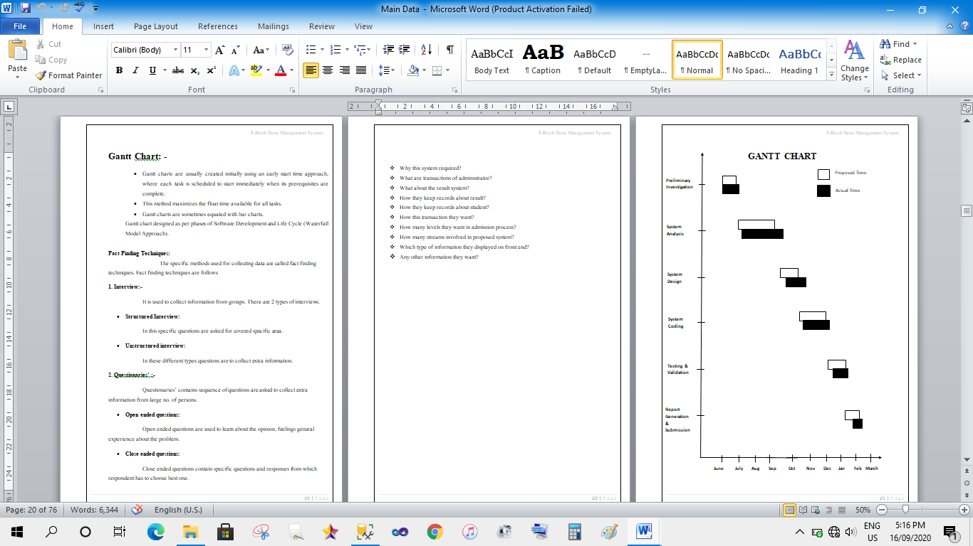

**Fact Finding Techniques**

To study the systems, require facts. Fact is also termed as data or information. A specific method used for collection data is called fact finding techniques.

**1. Interview:**

It is used to collect information from individuals or from groups. The interviewer must plan in advance and should know the problem under consideration.

There are two types of interview.

1) Structured Interview

2) Unstructured Interview

1) **Structured Interview:**

In this type of technique fixed type of question are asked and that questions covered in specific area. In this type of technique interview period may be short.

**2) Unstructured Interview:**

In this type of technique different type of question are asked and there is specific area. In this of fact-finding technique extra information may be collected.

**Questioners:**

Questioners are nothing but a question which asks to employ yes or to manager of organization. Questionnaires may be used supplements to interview. There are two types of questions which are considered in questionnaires.

1) Open ended questions

2) Closed ended questions

**1) Open ended questions:**

Open ended questions are used to learn about options, feelings and general experience about the problem.

**2) Closed ended questions:**

Closed ended questions contain specific Questionnaires responses from which respondent as to choose the best one.

**QUESTIONS:**

* When was the system established?
* Who is the owner of the system?
* Where is the main Centre of the system?
* How many departments are present in your system?
* How many employees do work in your system?
* What is the payment for each employee?
* How many reports are generated?
* Are all the transactions performed manually?
* Do you have software?

Software and Hardware Requirements

* **Software Used:**
* Front end: Microsoft Visual Studio 2010.
* Back end: Microsoft SQL Server 2017
* Operating System: Windows 10.
* Web Browser: Google Chrome, Mozilla Firefox.
* **Hardware Used:**
* Processor: Intel Core i5
* Memory: 4 GB RAM
* Storage: Minimum 5GB of Hard Disk Space.
* **Tools Used:**
* Crystal Report Viewer
* STAR UML Diagram Tool
* Microsoft Office Word 2010

Preliminary Product Description

Event table is a list of events of a system in rows and information about each event like.

**1] Trigger –** An occurrence that initiates the event which is either the arrival of data or of a point in time.

**2] Source –** An external agent or actor that supplies data to the System.

**3] Activity –** Behavior of the system due to the occurrence of the event.

**4] Response –** An output produced by the system as a result of the event.

**5] Destination –** An external agent or actor that receives the response generated by the system.

|  |  |  |  |  |  |
| --- | --- | --- | --- | --- | --- |
| **Event** | **Trigger** | **Source** | **Activity** | **Response** | **Destination** |
| Customer Registration | Customer arrival | Customer | Requesting | Registration Successful | System |
| Employee Master | Customer arrival | Customer | Give Registration | Registration Successful | System |
| Employee give Watersports Details | Watersports Details | Employee | Store Information | Accepts Information | System |
| Update Information | Database Profile | Owner/ Employee/Customer | Access to the database | Manipulation of data | Database updation database server |

**Conceptual Model**

**Submit/Register me/Add:**

By clicking this button data is stored on server and all the controls get refreshed and cleared. Then it will be ready for new record.

**Clear/Back/Cancel:**

By clicking this button all the controls get refreshed and cleared. Then it will be ready for next record to enter.

**Login:**

Used for logging in to the system

**Save:**

This button is used to update the records.

**Save:**

This button is used to save the records.

**Delete:**

Admin or Employee can delete data by clicking Delete button.

**Get Receipt:**

Employee can get receipt by clicking Get Receipt.

**System Flow Chart**

Following symbols used to draw system flowchart

|  |  |
| --- | --- |
| **Symbols** | **Name** |
|  | Used for process |
|  | Used for predefined process |
|  | Used for documents |
|  | Used for manual operation |
|  | Used for online storage |
|  | Used for direct access file |
|  | Used for manual input |
|  | Used for display |

**System Flow Chart**

Employee Prints Receipt

Login to system

Admin or/and Employee

Customer Make Payment

Customer do visit

Select Watersports

Select Rounds

Book Watersports

**Entity Relationship Diagram**

An entity relationship diagram (ERD) shows the relationships of entity sets stored in a database. An entity in this context is a component of data. In other words, ER diagrams illustrate the logical structure of databases.

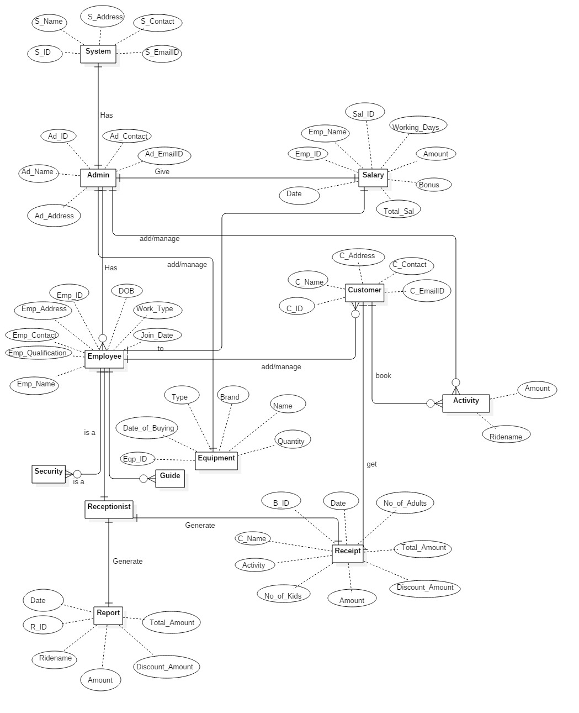**ER Diagram:**

**Class Diagram**

A class diagram models the static structure of a system. It shows relationships between classes, objects, attributes, and operations.

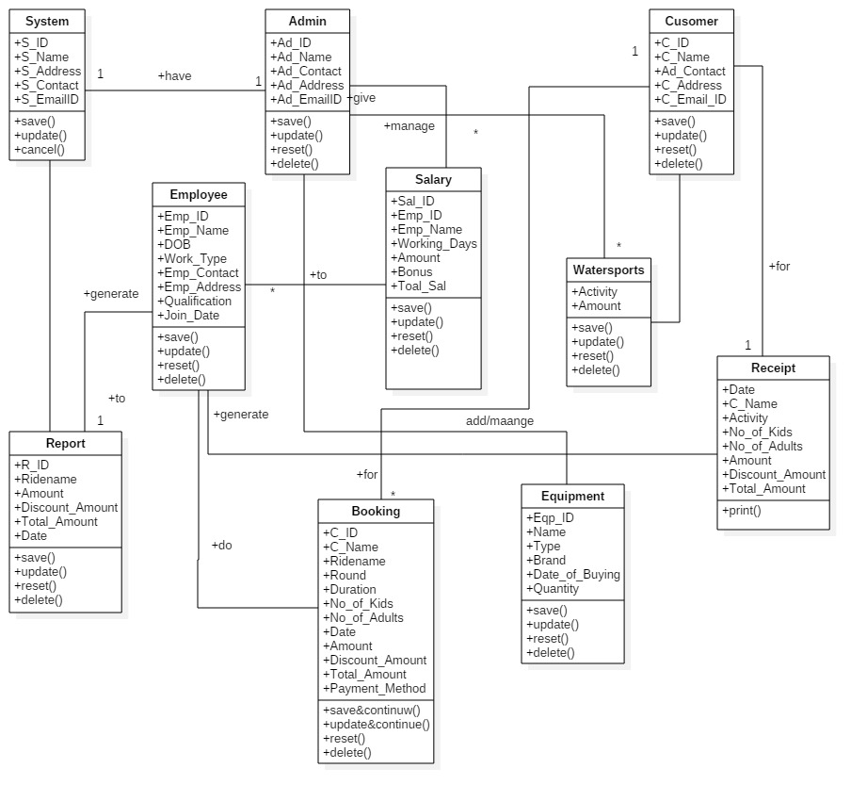**Class Diagram:**

**Object Diagram**

Object diagrams, or instance diagram, illustrate objects and links. As in the case of class diagrams, object diagrams represent the static structure. The notation used for object diagrams is derived from that of class diagrams; elements that are instances are underlined.

Object diagrams are primarily used to show a context –before or after an interaction, for example. However, they are also used to aid the understanding of complex data structures, such as recursive structure.

**Object Diagram:**

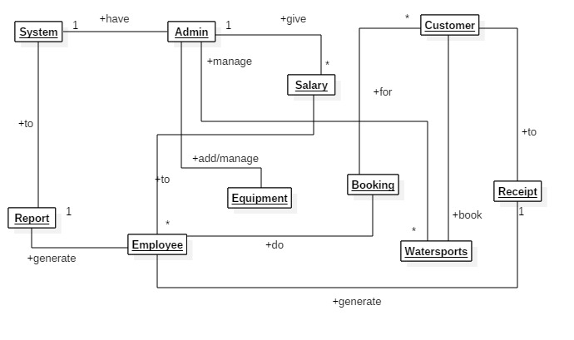

**Package Diagram**

A package can be represented as hierarchical structure with nested packages. Atomic nested package are usually class diagrams. The model diagram allows to show different view of system.

**TVS watersports management system(Main)**

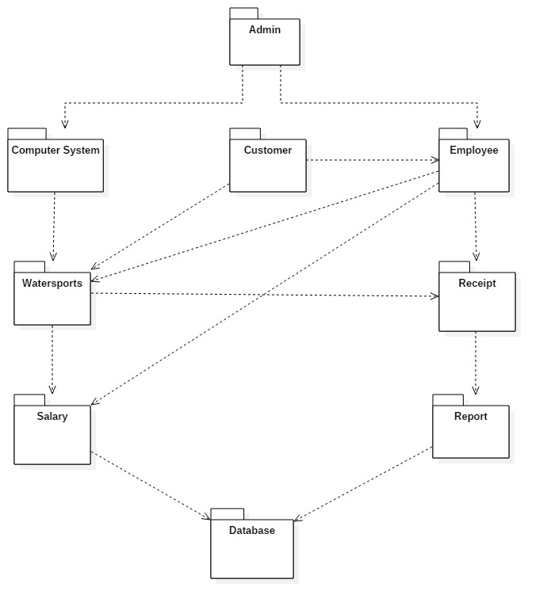

**Component Diagram**

Presence of association and role information shows that the diagram represents classes of nodes the diagram shows a system composed of a server with the surrounding Pc’s that drive the opening and closing gates.

**Component Diagram:**

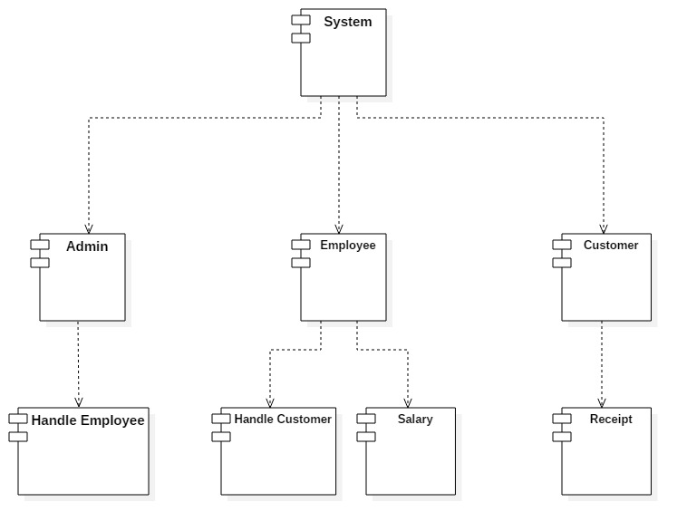

**Deployment Diagram**

The diagram shows physical layout various hardware component that compose a system as well as the substitution of executable program on this hardware.

**Deployment Diagram:**

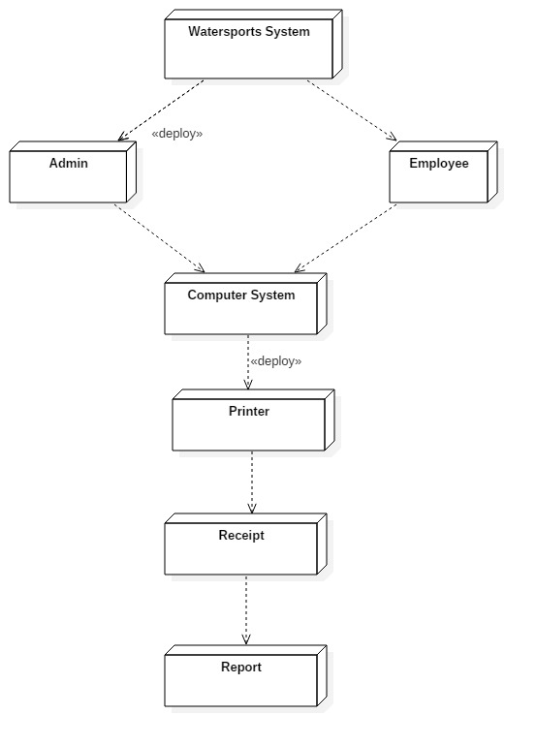

**CHAPTER - IV**

**System Design**

**Basic Module**

Watersports Management system provides the module like

* System.
* Admin.
* Employee.
* Customer.

**System**

The system should create profile of owner and their employee that work by the instructions of owner. System can store records about customer and user that is owner and employee. System should be creating many tasks by the owner.

Maintain system records

View customer details

Employee Profile

Owner Profile

Login

System

**Admin:**

The admin is the system in-charge who views the customer detail and employee detail. Giving salary to the employee and handle them. Log in to the system.

Give Salary to Employee

View Customers & Employee Details

Admin

Login

**Employee:**

The employee handles customers and views their information and updates their details. Employee does booking of the watersports and generate receipt for them.

Employee

Handle Customer

Book Watersports

Generate Receipt

Give Receipt to the Customer

**Customer:**

In this module, Creation of customer input records about customer details like name, age, DOB, address etc. with facilities to modify the records and viewing changed records.

Enquires for Watersports

Book Watersports

Customer

Get Receipt

Make Payment

**Data Design**

**Schema Design:**

**Table Name: Registration**

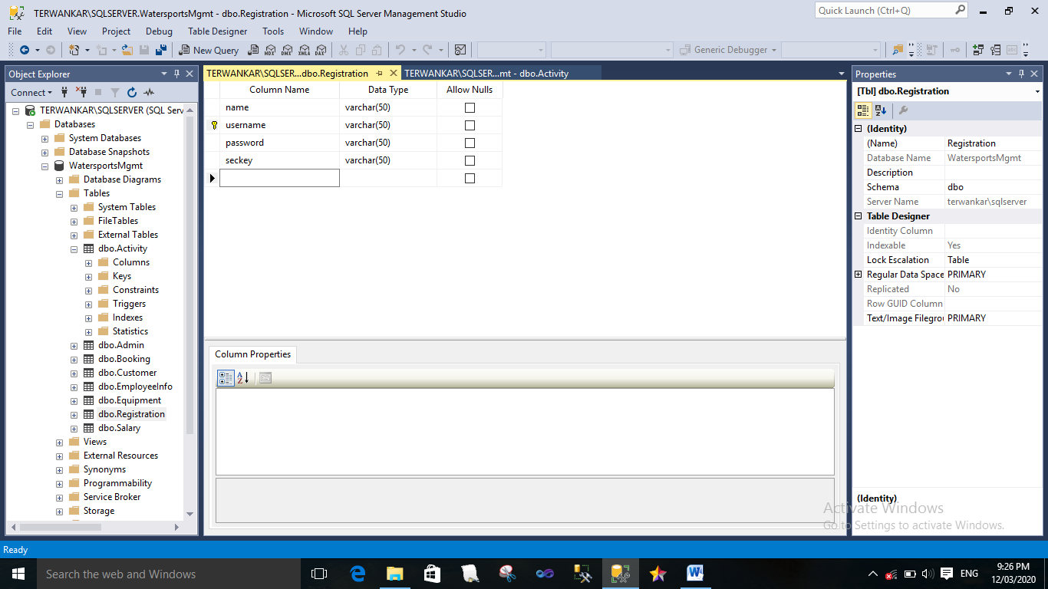

**Table Description:** This table keeps information about admin login, employee login to the system. And also keep information of change password and forgot password.

**Table Name: Activity**

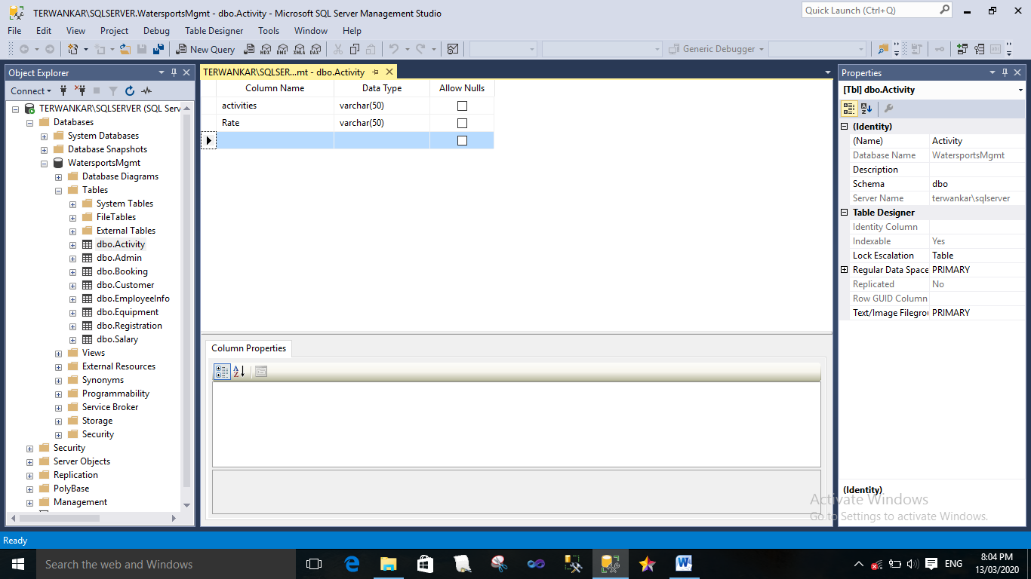

**Table Description:** This table keeps the information about watersport’s activity.

**Table Name:** **Admin**

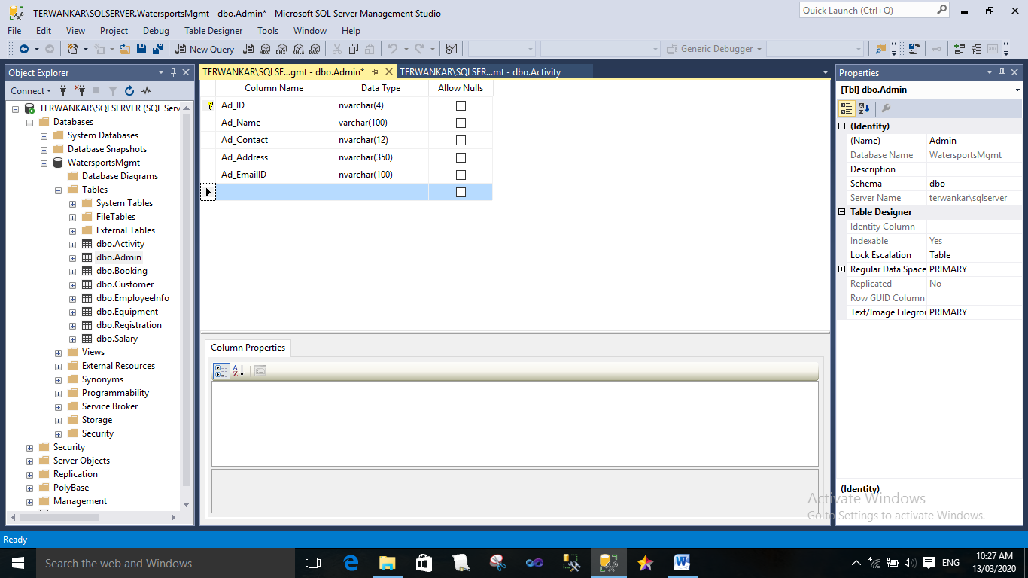

**Table Description:** This table keeps information about admin of system.

**Table Name: Employee**

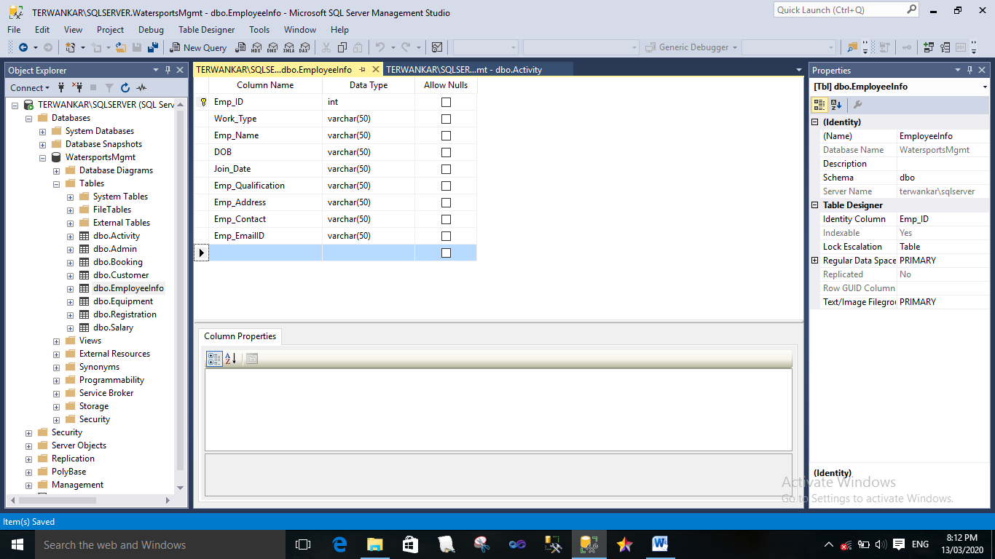

**Table Description:** This table keeps information about employee.

**Table Name: Salary**

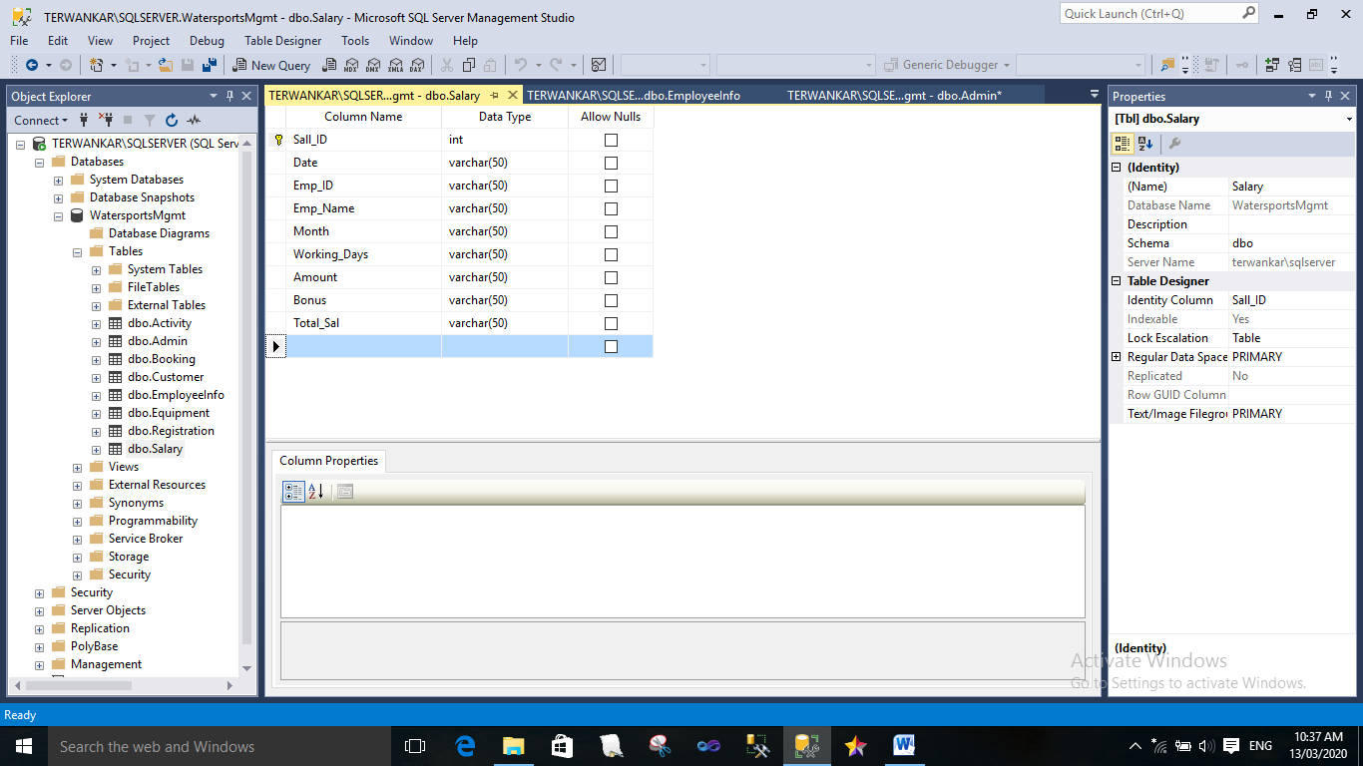

**Table Description:** This table keeps information about the salary of employee.

**Table Name: Customer**

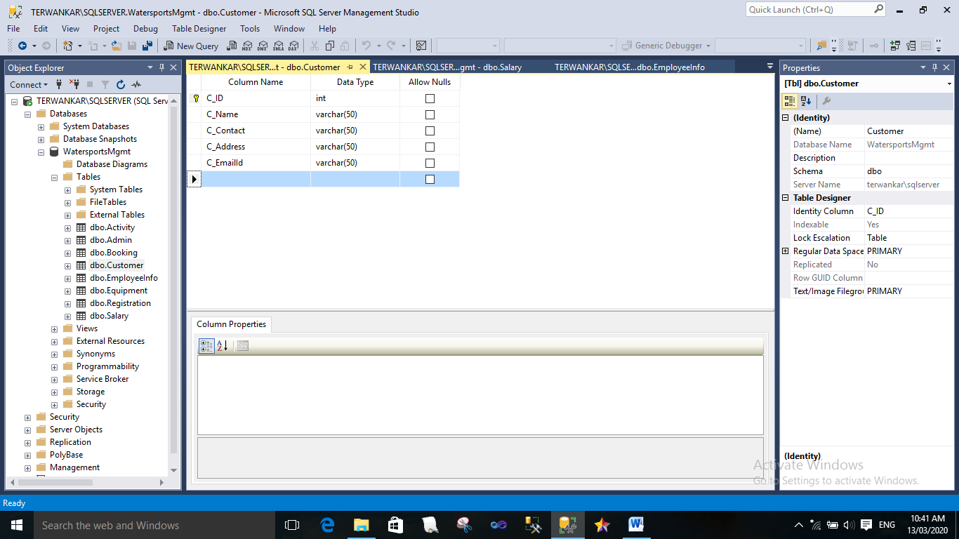

**Table Description:** This table keeps information about customers.

**Table Name: Booking**

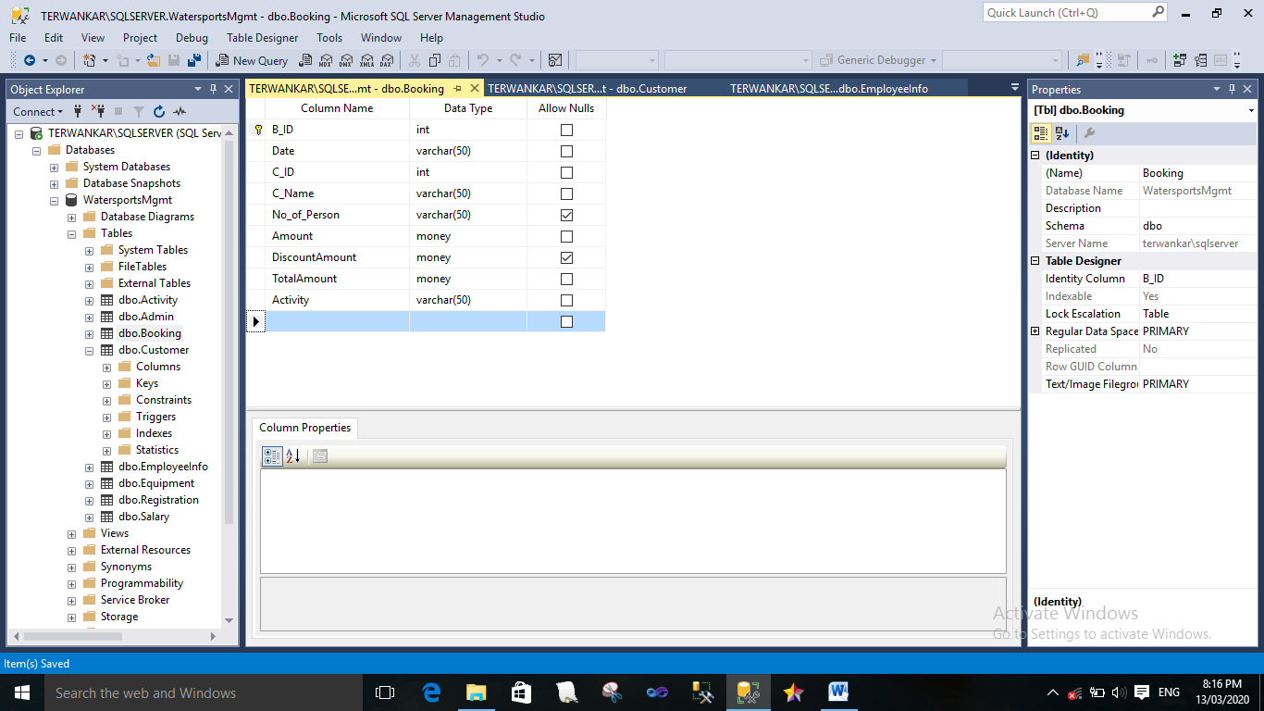

**Table Description:** This table keeps information about booking of watersports.

**Table Name: Equipment**

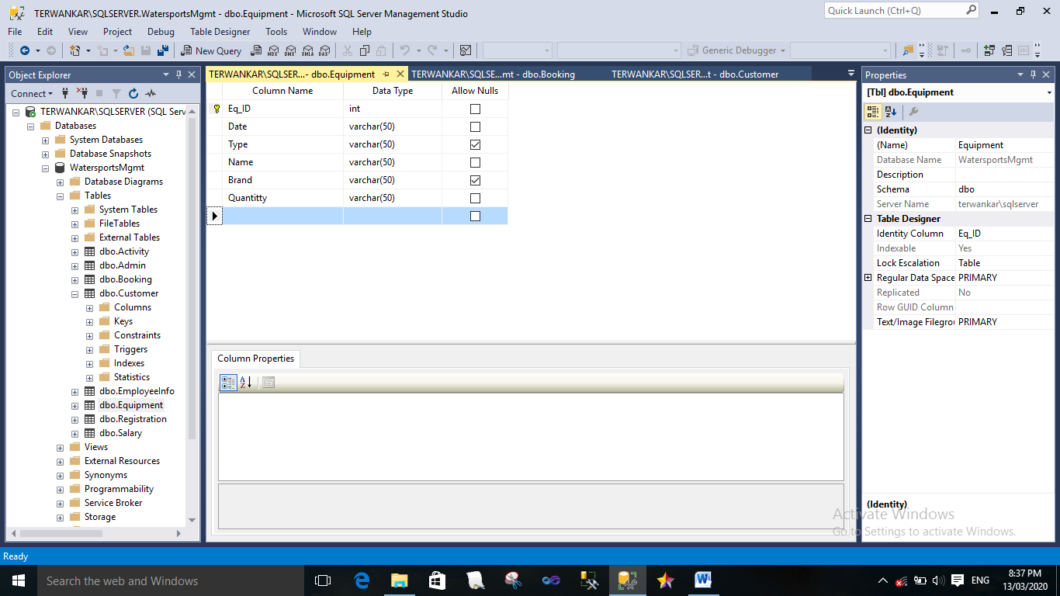

**Table Description:** This table keeps information about equipments of watersports.

**Data Integrity and Constrains:**

**Table Name: Registration**

|  |  |  |  |
| --- | --- | --- | --- |
| **Field Name** | **Data Type** | **Integrity Constraint** | **Description** |
| username | varchar | Not null | Username of the admin or employee |
| password | varchar | Not null | Password for admin or employee |
| seckey | varchar | Not null | Security key |

**Table Description:** This table keeps information about admin login, customer login to the system. And also keep information of change password and forgot password.

**Table Name: Activity**

|  |  |  |  |
| --- | --- | --- | --- |
| **Field Name** | **Data Type** | **Integrity Constraint** | **Description** |
| activities | varchar | Not null | ID of admin |
| Rate | varchar | Not null | Name of admin |

**Table Description:** This table keeps the information about watersport’s activity.

**Table Name:** **Admin**

|  |  |  |  |
| --- | --- | --- | --- |
| **Field Name** | **Data Type** | **Integrity Constraint** | **Description** |
| Ad_ID | nvarchar | Primary key | ID of admin |
| Ad_Name | varchar | Not null | Name of admin |
| Ad_Contact | nvarchar | Not null | Phone no. Of admin |
| Ad_Address | nvarchar | Not null | Address of admin |
| Ad_EmailID | nvarchar | Not null | Email ID of admin |

**Table Description:** This table keeps information about admin of system.

**Table Name: Employee**

|  |  |  |  |
| --- | --- | --- | --- |
| **Field Name** | **Data Type** | **Integrity Constraint** | **Description** |
| Emp_ID | int | Primary key | ID of employee |
| Work_Type | varchar | No null | Work type of employee |
| Emp_Name | varchar | Not null | Name of employee |
| DOB | varchar | Not null | Birth date of employee |
| Join_Date | varchar | Not null | Joining date of employee |
| Emp_Qualification | varchar | No null | Qualification of employee |
| Emp_Address | varchar | Not null | Address of employee |
| Emp_Contact | varchar | Not null | Phone no. Of employee |
| Emp_EmailID | varchar | Not null | Email ID of employee |

**Table Description:** This table keeps information about employee.

**Table Name: Salary**

|  |  |  |  |
| --- | --- | --- | --- |
| **Field Name** | **Data Type** | **Integrity Constraint** | **Description** |
| Sall_ID | int | Primary Key | ID of Salary |
| Date | varchar | Not null | Current date |
| Emp_ID | varchar | Foreign key | ID of employee |
| Emp_Name | varchar | Not null | Name of employee |
| Month | varchar | Not null | Month of the salary |
| Working_Days | varchar | Not null | Working days of employee |
| Amount | varchar | Not null | Amount of salary |
| Bonus | varchar | Not null | Bonus on salary |
| Total_Sal | varchar | Not null | Total salary of employee |

**Table Description:** This table keeps information about the salary of employee.

**Table Name: Customer**

|  |  |  |  |
| --- | --- | --- | --- |
| **Field Name** | **Data Type** | **Integrity Constraint** | **Description** |
| C_ID | int | Primary key | ID of customer |
| C_Name | varchar | Not null | Name of customer |
| C_Contact | varchar | Not null | Phone no. Of customer |
| C_Address | varchar | Not null | Address of customer |
| C_EmailId | varchar | Not null | Email ID of customer |

**Table Description:** This table keeps information about customers.

**Table Name: Booking**

|  |  |  |  |
| --- | --- | --- | --- |
| **Field Name** | **Data Type** | **Integrity Constraint** | **Description** |
| B_ID | int | Primary key | Booking ID |
| Date | varchar | Not null | Date of booking |
| C_ID | int | Not null | Customer’s ID |
| C_Name | varchar | Not null | Name of customer |
| No_of_Person | varchar | Null | Number of Persons |
| Amount | money | Not null | Amount of activities |
| DiscountAmount | money | Null | Discount amount on activities |
| TotalAmount | money | Not Null | Total Amount of activities |
| Activity | varchar | Not Null | Activity of the watersports |

**Table Description:** This table keeps information about booking of watersports.

**Table Name: Equipment**

|  |  |  |  |
| --- | --- | --- | --- |
| **Field Name** | **Data Type** | **Integrity Constraint** | **Description** |
| Eq_ID | int | Primary key | ID of Equipment |
| Date | varchar | Not null | Date of buying of equipment |
| Type | varchar | Null | Type of equipment |
| Name | varchar | Not null | Name of the equipment |
| Brand | varchar | Null | Brand of equipment |
| Quantity | varchar | Not Null | Quantity of Equipment |

**Table Description:** This table keeps information about Equipment.

**Procedural Design**

**Logic Diagrams**

**Use Case Diagram**

A Use Case Diagram at its simplest is a representation of a user interaction with the system that shows the relationship between the user and different use case in which the user is involved.

**Use case Diagram:**

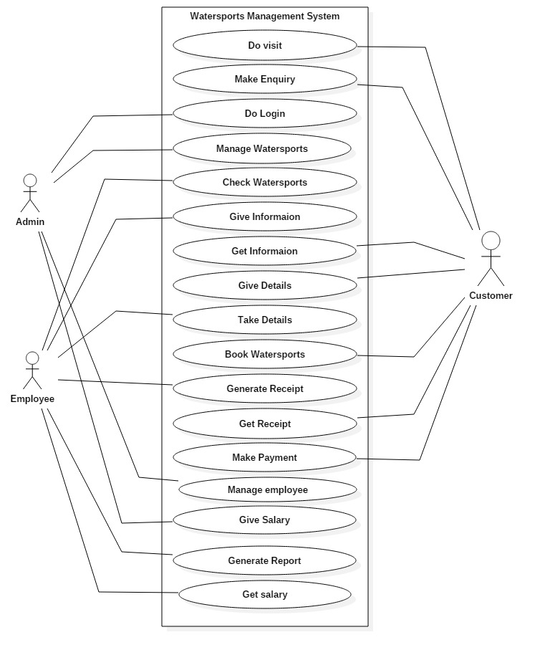

**Sequence Diagram**

Sequence diagram shows the sequence of the interaction between object that occurs during the flow of event of single scenario or use case.

**Sequence Diagram:**

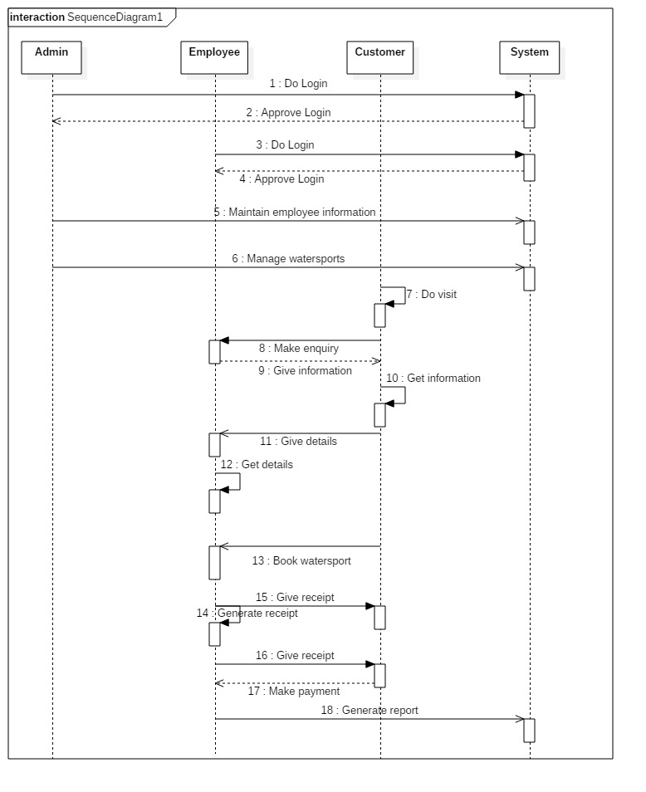

**State Transition Diagram**

State transition diagrams have been used right from the beginning in object-oriented modeling. The basic idea is to define a machine that has a number of states (hence the term finite state machine).

**State Transition Diagram:**

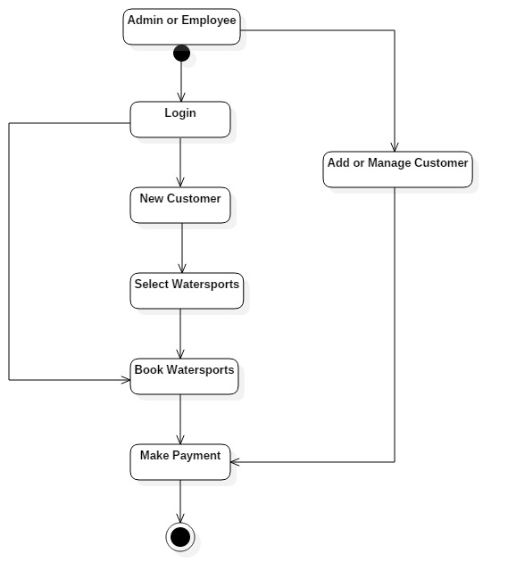

**Activity Diagram**

An activity diagram is a variant of state chart diagram organized according to actions and mainly targeted towards representing the internal behaviour of a method or a use case. An activity diagrams another important behavioural diagram in UML to describe dynamic aspects of the system. Activity diagram is essentially an advanced version of flow chart that modelling the flow from one activity to another activity.

**Activity Diagram:**

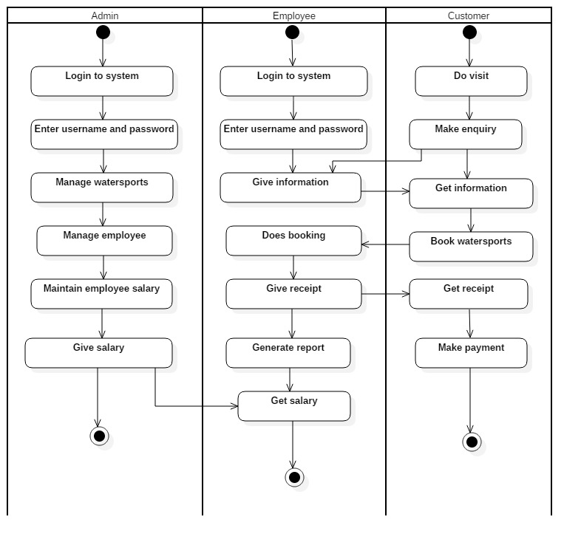

**Data Structures**

Different Data Structure are commonly use universally. Queues have variety of uses for the purpose of messaging. Stack or Heap are used. Graphs are indispensable in variety of application – Social network, mapping and geo-location application, web indexing /search.

The various data structure can be used are as follow:

1. Dynamic:

The size of the array will be increased when the container is full and decreased when the container is one-quarter full.

1. Linked:

The container will be made up of linked list of array of fixed size. When one array is filled, a new node will be added with new array.

1. Navigation Stack:

A stack with additional backward and forward operation minimizes the behavior of the recording events to allow undo and redo operation.

1. Range Stack:

A stack that record not only the entries but also the current minimum and maximum entries in the stack. This can be implemented by having three arrays or a stack of a struct containing three entries.

1. Dual Stack:

One array permits two stacks, one growing from each end.

1. Droff-off Stack:

A stack where, if the stack is full, discards what is currently at the bottom of the stack and places the new object on the top.

Tree Based Date Structure:

1. AVL Tree.
2. B-Tree.
3. File System.

Table Data Structure:

1. Binary Heap
2. Hash Table.

Graph Data Structure & algorithms:

1. Dijkstra’s algorithm
2. Prim’s algorithm
3. Kruskal algorithm

**Algorithm Design**

A data flow is graphical algorithmic tool used to describe and analyze the movement of data through a system by depicting the flow of data, storage of data.

It Defines:

1. System Process
2. Data Store
3. The Information flows in the system.
4. Any external entities that interact with the system (Source & destination of data.)

**User Interface Design**

User: User may admin or employee. Employee Logins to system and book Activity & update information in system.

**MDI Form:**

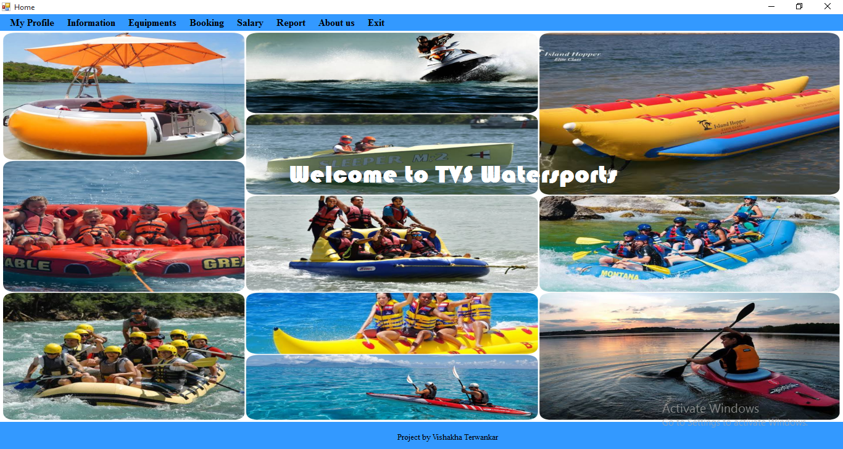

**Registration:**

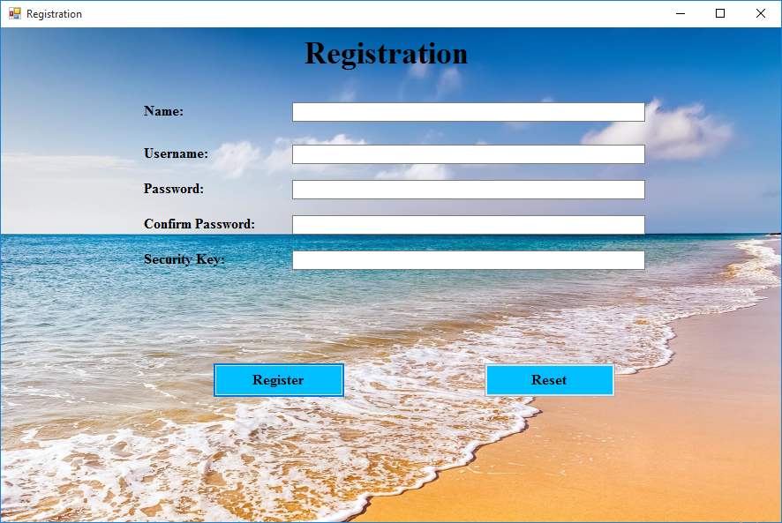

**Login:**

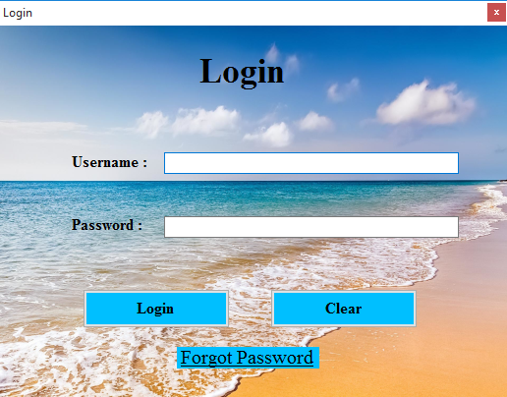

**Forgot Password:**

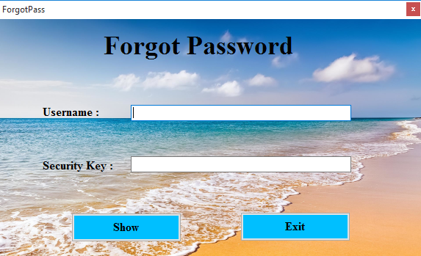

**Change Password:**

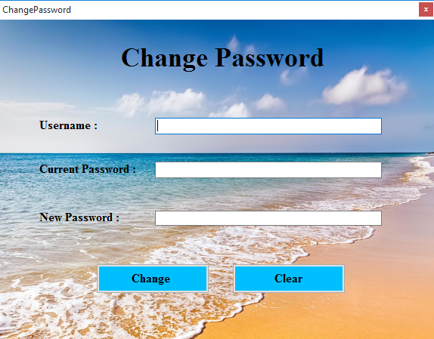

**Admin Information:**

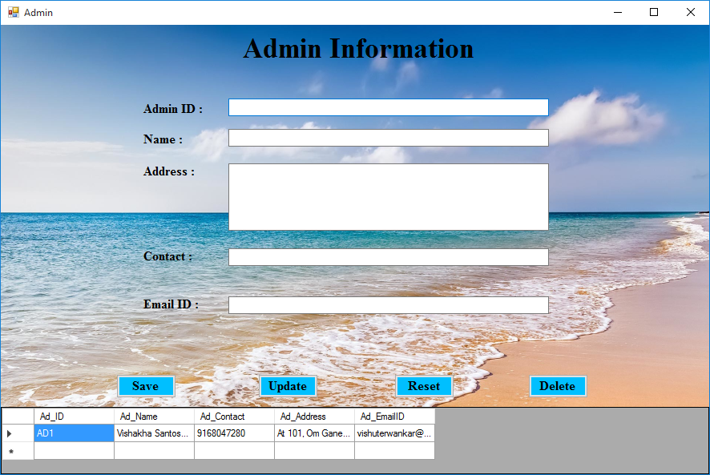

**Employee Information:**

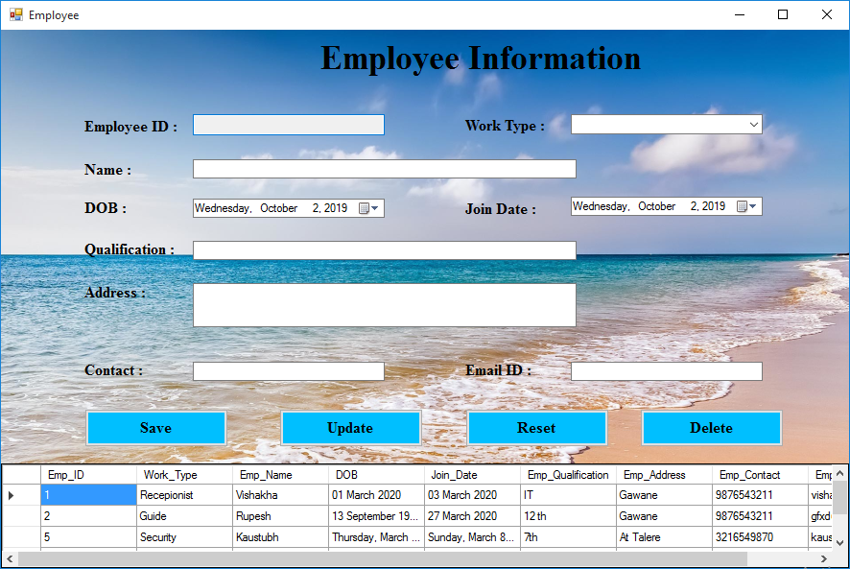

**Customer Information:**

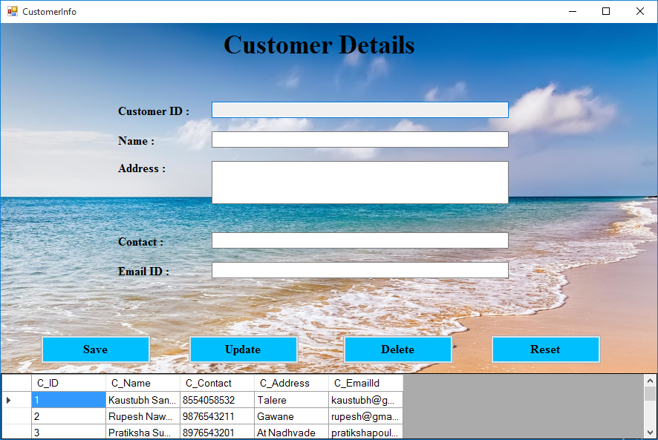

**Employee Salary:** 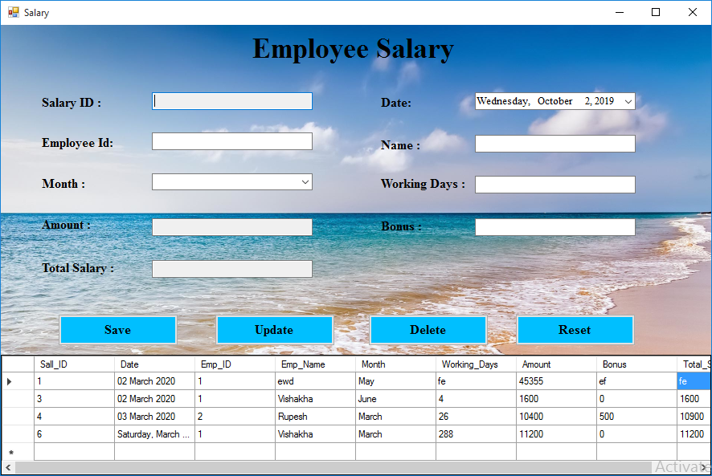

**Booking:**

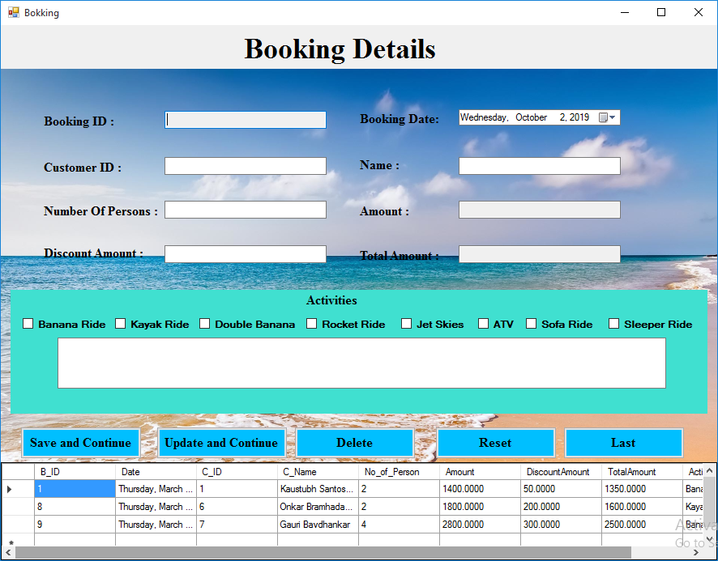

**Receipt:** 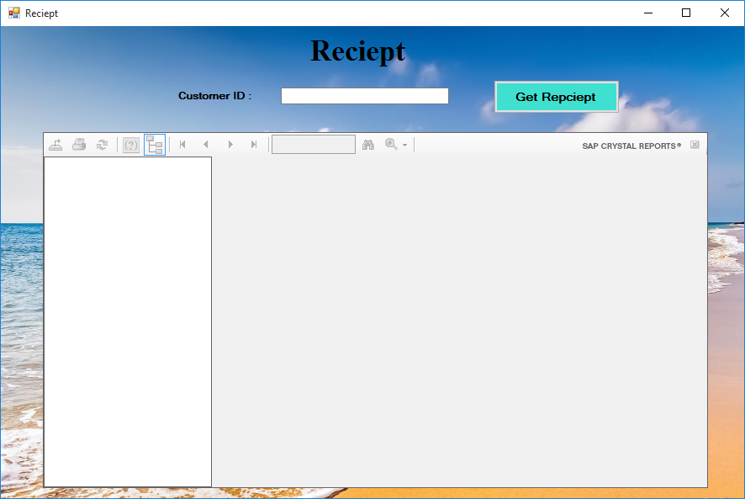

**Equipment Details:**

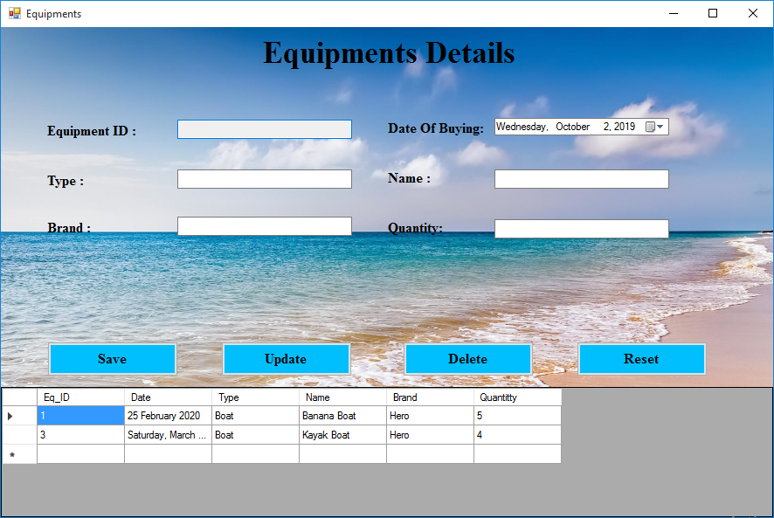

**About us Form:**

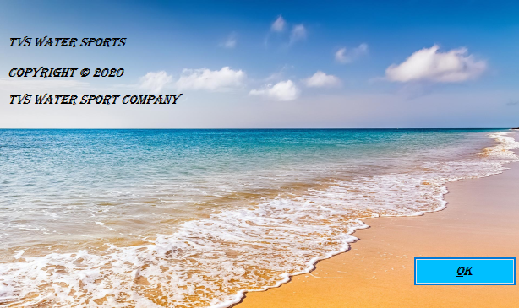

**Security Issues**

**Most common security issues are applicable for the project:**

1. SQL Injection
2. System Failure
3. Power Cuts
4. Hardware Failure

**Test Case Design**

**Some Test Cases for project are as follow:**

|  |  |  |  |  |  |  |  |
| --- | --- | --- | --- | --- | --- | --- | --- |
| **Test Case ID** | **Test Case** | **Test Condition** | **Step To Be Execution** | **Expected Result** | **Actual Result** | **Pass/Fail** | **Comment** |
| A001 | Admin Login | Try to access user name & Password | 1. Enter User name & Password | Admin Login Successful | As Expected | Pass |  |
| 2. Click on Submit Button |
| A002 | Admin Login | Try to access Invalid user name & Valid Password | 1. Enter Invalid User name. | Display error message to enter valid user name. | As Expected | Pass |  |
| 2. Enter Valid Password |
| 3. Click on submit button. |
| A003 | Admin Login | Try to access valid user name & invalid Password | 1. Enter valid User name. | Display error message to enter valid password. | As Expected | Pass |  |
| 2. Enter invalid Password |
| 3. Click on submit button. |
| A004 | Admin Login | Try to access invalid user name & invalid Password | 1. Enter invalid User name. | Display error message to enter valid username & password. | As Expected | Pass |  |
| 2. Enter invalid Password |
| 3. Click on submit button. |
| A005 | Admin Login | Try to access Only user name | 1. Enter valid User name. | Display error message to enter valid password. | As Expected | Pass |  |
| 2. Do not enter Password |
| 3. Click on submit button. |
| A006 | Admin Login | Try to access Only password | 1. Do not enter User name. | Display error message to enter valid user name. | As Expected | Pass |  |
| 2. Enter valid Password |
| 3. Click on submit button. |
| A007 | Admin Login | Try to access Submit button | 1. Do not enter User name. | Display error message to enter valid username & password. | As Expected | Pass |  |
| 2. Do not enter Password |
| 3. Click on submit button. |
| A008 | Admin Login | Try to access user name & Password | 1. Enter Case changed User name | Display error message to enter valid username & password. | As Expected | Pass |  |
| 1. Enter Case changed password |
| 3. Click on Submit Button |
| A009 | Open forgot password form | Try to access forgot password form | 1. Click on forgot password link. | Open forgot password form |  |  |  |
|
|
| A010 | Open change password form | Try to access change password form | 1. Click on change password link. | Open change password form |  |  |  |
|
|

|  |  |  |  |  |  |  |  |
| --- | --- | --- | --- | --- | --- | --- | --- |
| **Test Case ID** | **Test Case** | **Test Condition** | **Step To Be Execution** | **Expected Result** | **Actual Result** | **Pass/Fail** | **Comment** |
| F001 | Forgot Password | Try to access user name & Security key | 1. Enter User name & Security key | Show Password | As Expected | Pass |  |
| 2. Click on Show Button |
| F002 | Forgot Password | Try to access Invalid user name & Valid Security key | 1. Enter Invalid User name. | Display error message to enter valid user name. | As Expected | Pass |  |
| 2. Enter Valid Security key |
| 3. Click on show button. |
| F003 | Forgot Password | Try to access valid user name & invalid Password | 1. Enter valid User name. | Display error message to enter valid Security key | As Expected | Pass |  |
| 2. Enter invalid Security key |
| 3. Click on show button. |
| F004 | Forgot Password | Try to access invalid user name & invalid Security key | 1. Enter invalid User name. | Display error message to enter valid username & Security key | As Expected | Pass |  |
| 2. Enter invalid Security key |
| 3. Click on show button. |
| F005 | Forgot Password | Try to access Only user name | 1. Enter valid User name. | Display error message to enter valid Security key. | As Expected | Pass |  |
| 2. Do not enter Security key |
| 3. Click on show button. |
| F006 | Forgot Password | Try to access Only Security key | 1. Do not enter User name. | Display errors message to enter valid user name. | As Expected | Pass |  |
| 2. Enter valid Security key |
| 3. Click on show button. |
| F007 | Forgot Password | Try to access show button | 1. Do not enter User name. | Display error message to enter valid username & Security key | As Expected | Pass |  |
| 2. Do not enter Security key |
| 3. Click on show button. |
| F008 | Forgot Password | Try to access user name & Security key | 1. Enter Case changed User name | Display errors message to enter valid username & Security key | As Expected | Pass |  |
| 1. Enter Case changed Security key |
| 3. Click on show Button |
| F009 | Forgot Password | Try to access cancel button | 1. Click on cancel button | Close forgot password form | As Expected | Pass |  |

**CHAPTER - V**

**IMPLEMENTATION AND TESTING**

Implementation of Watersports Management System is to make easy way for booking of Watersports to the customer and also for the owner.

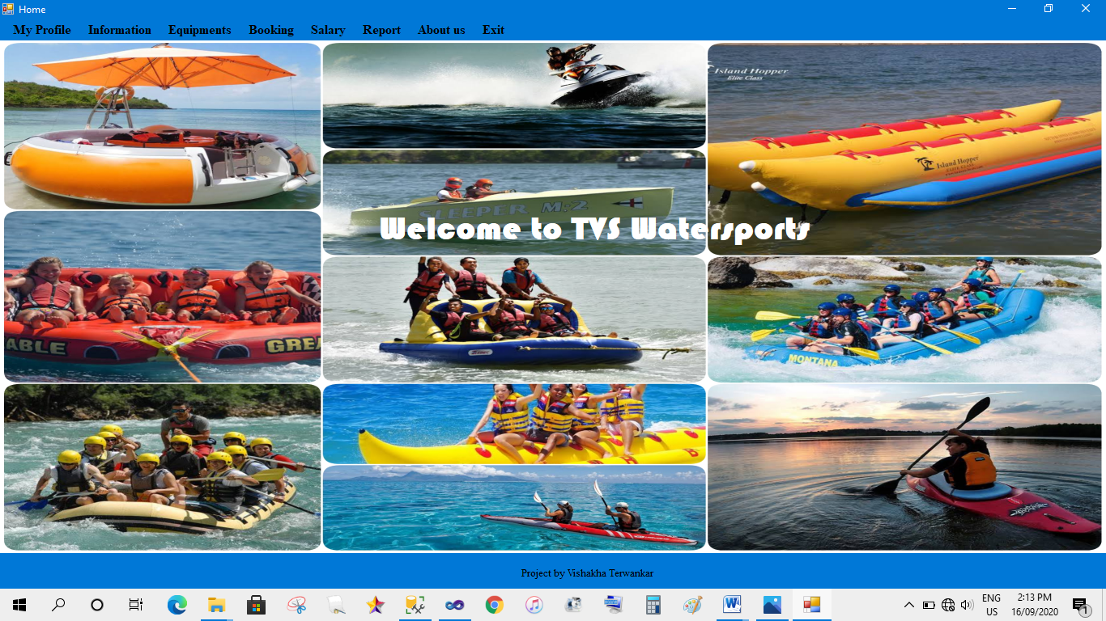**Home:**

**Code:**

using System;

using System.Collections.Generic;

using System.ComponentModel;

using System.Data;

using System.Drawing;

using System.Linq;

using System.Text;

using System.Windows.Forms;

namespace WatersportsManagement

{

public partial class Home : Form

{

private int childFormNumber = 0;

public Home()

{

InitializeComponent();

}

private void ShowNewForm(object sender, EventArgs e)

{

Form childForm = new Form();

childForm.MdiParent = this;

childForm.Text = "Window " + childFormNumber++;

childForm.Show();

}

private void OpenFile(object sender, EventArgs e)

{

OpenFileDialog openFileDialog = new OpenFileDialog();

openFileDialog.InitialDirectory = Environment.GetFolderPath(Environment.SpecialFolder.Personal);

openFileDialog.Filter = "Text Files (*.txt)|*.txt|All Files (*.*)|*.*";

if (openFileDialog.ShowDialog(this) == DialogResult.OK)

{

string FileName = openFileDialog.FileName;

}

}

private void SaveAsToolStripMenuItem_Click(object sender, EventArgs e)

{

SaveFileDialog saveFileDialog = new SaveFileDialog();

saveFileDialog.InitialDirectory = Environment.GetFolderPath(Environment.SpecialFolder.Personal);

saveFileDialog.Filter = "Text Files (*.txt)|*.txt|All Files (*.*)|*.*";

if (saveFileDialog.ShowDialog(this) == DialogResult.OK)

{

string FileName = saveFileDialog.FileName;

}

}

private void ExitToolsStripMenuItem_Click(object sender, EventArgs e)

{

this.Close();

}

private void CutToolStripMenuItem_Click(object sender, EventArgs e)

{

}

private void CopyToolStripMenuItem_Click(object sender, EventArgs e)

{

}

private void PasteToolStripMenuItem_Click(object sender, EventArgs e)

{

}

private void CascadeToolStripMenuItem_Click(object sender, EventArgs e)

{

LayoutMdi(MdiLayout.Cascade);

}

private void TileVerticalToolStripMenuItem_Click(object sender, EventArgs e)

{

LayoutMdi(MdiLayout.TileVertical);

}

private void TileHorizontalToolStripMenuItem_Click(object sender, EventArgs e)

{

LayoutMdi(MdiLayout.TileHorizontal);

}

private void ArrangeIconsToolStripMenuItem_Click(object sender, EventArgs e)

{

LayoutMdi(MdiLayout.ArrangeIcons);

}

private void CloseAllToolStripMenuItem_Click(object sender, EventArgs e)

{

foreach (Form childForm in MdiChildren)

{

childForm.Close();

}

}

private void changePasswordToolStripMenuItem_Click(object sender, EventArgs e)

{

ChangePassword child = new ChangePassword();

child.Owner = this;

child.Show();

}

private void employeeToolStripMenuItem_Click(object sender, EventArgs e)

{

Employee child = new Employee();

child.Owner = this;

child.Show();

}

private void customerToolStripMenuItem_Click(object sender, EventArgs e)

{

CustomerInfo child = new CustomerInfo();

child.Owner = this;

child.Show();

}

private void toolStripMenuItem1_Click(object sender, EventArgs e)

{

Salary child = new Salary();

child.Owner = this;

child.Show();

}

private void aboutUsToolStripMenuItem_Click(object sender, EventArgs e)

{

Aboutus child = new Aboutus();

child.Owner = this;

child.Show();

}

private void toolStripMenuItem2_Click(object sender, EventArgs e)

{

this.Close();

}

private void registrationToolStripMenuItem_Click(object sender, EventArgs e)

{

Registration child = new Registration();

child.Owner = this;

child.Show();

}

private void bookingToolStripMenuItem_Click(object sender, EventArgs e)

{

}

private void recieptPrintToolStripMenuItem_Click(object sender, EventArgs e)

{

Reciept child = new Reciept();

child.Owner = this;

child.Show();

}

private void bookingReportToolStripMenuItem_Click(object sender, EventArgs e)

{

BookingReport child = new BookingReport();

child.Owner = this;

child.Show();

}

private void equipmentReportToolStripMenuItem_Click(object sender, EventArgs e)

{

EquipmentReport child = new EquipmentReport();

child.Owner = this;

child.Show();

}

private void employeeReportToolStripMenuItem_Click(object sender, EventArgs e)

{

EmployeeReport child = new EmployeeReport();

child.Owner = this;

child.Show();

}

private void salaryReportToolStripMenuItem_Click(object sender, EventArgs e)

{

SalaryReport child = new SalaryReport();

child.Owner = this;

child.Show();

}

private void bookingToolStripMenuItem1_Click(object sender, EventArgs e)

{

Bokking child = new Bokking();

child.Owner = this;

child.Show();

}

private void equipmentsToolStripMenuItem_Click(object sender, EventArgs e)

{

Equipments child = new Equipments();

child.Owner = this;

child.Show();

}

private void myProfileToolStripMenuItem_Click(object sender, EventArgs e)

{

}

private void adminToolStripMenuItem_Click(object sender, EventArgs e)

{

Admin child = new Admin();

child.Owner = this;

child.Show();

}

private void Home_Load(object sender, EventArgs e)

{

}

}

}

**Registration:**

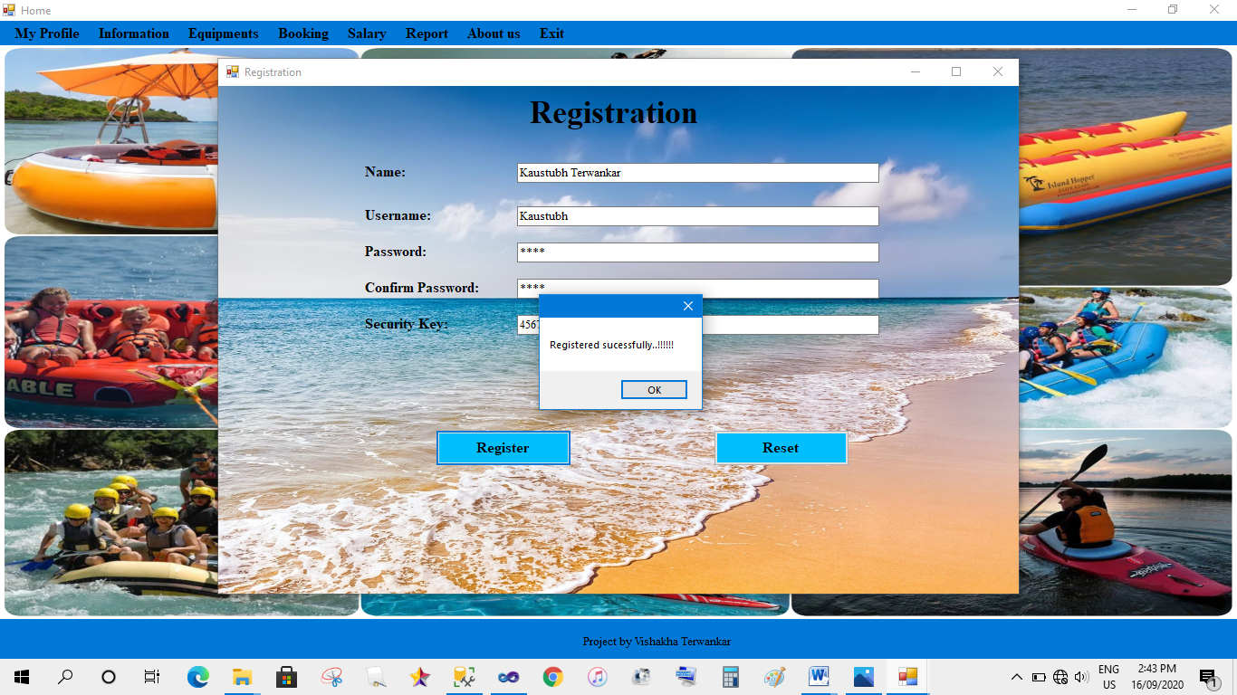

**Login:**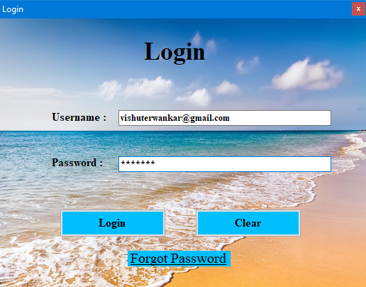

**Forgot Password:**

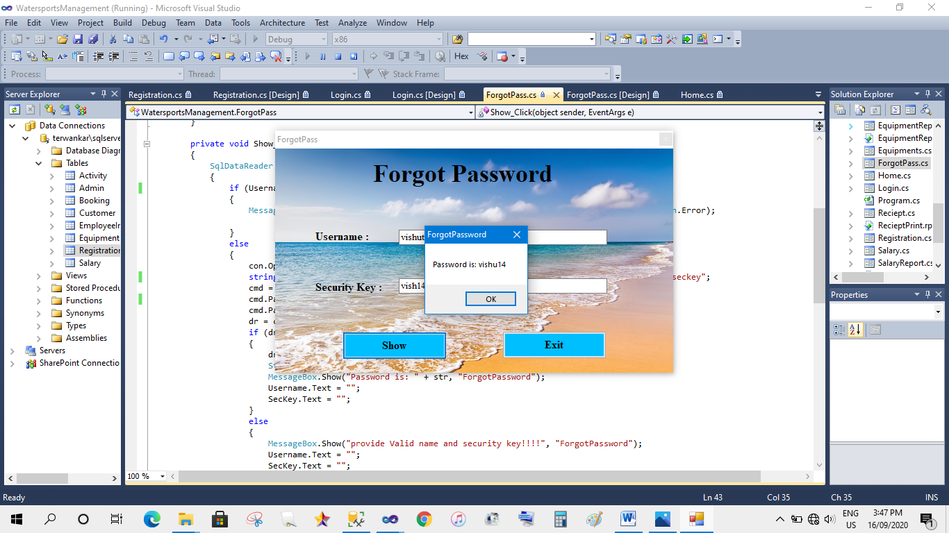

**Change Password:**

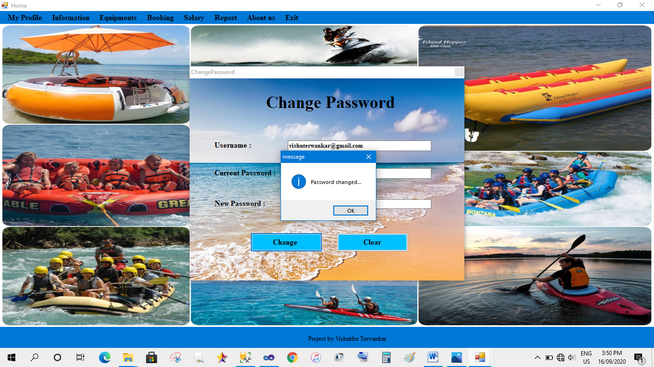

**Admin Information:**

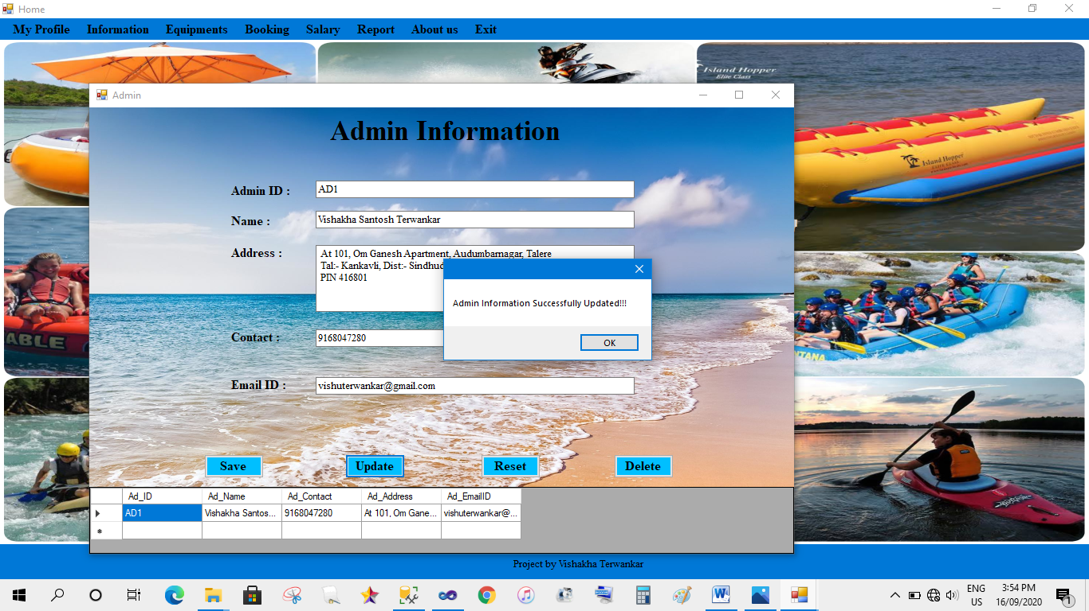

**Employee Information:**

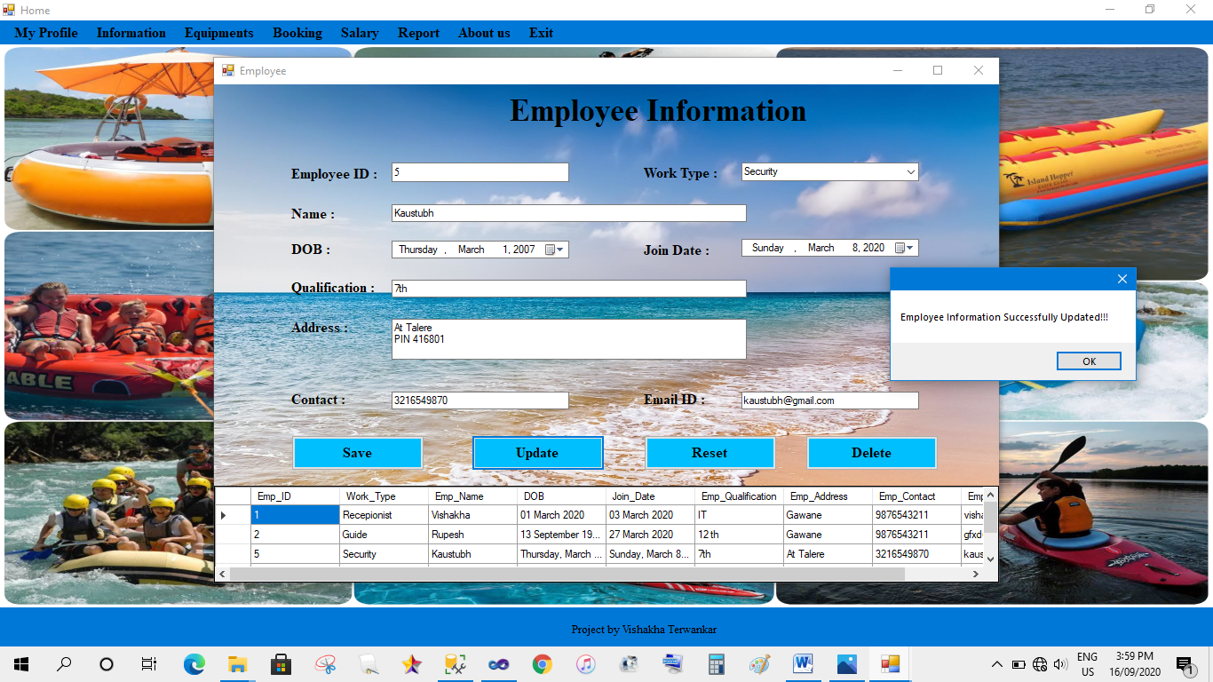

**Customer Information:**

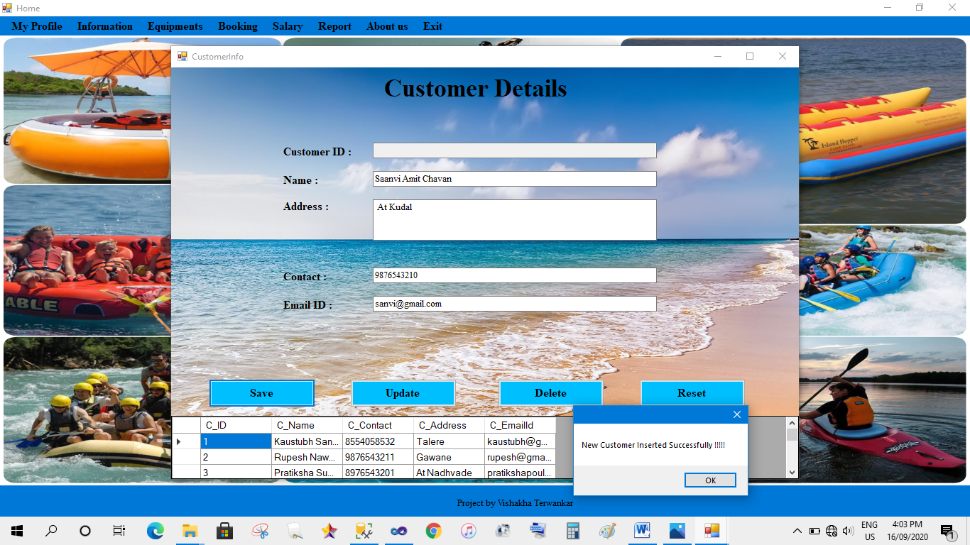

**Employee Salary:**

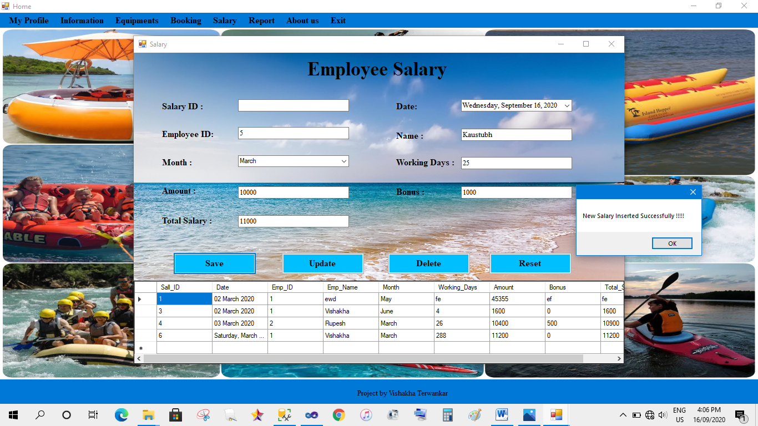

**Booking:**

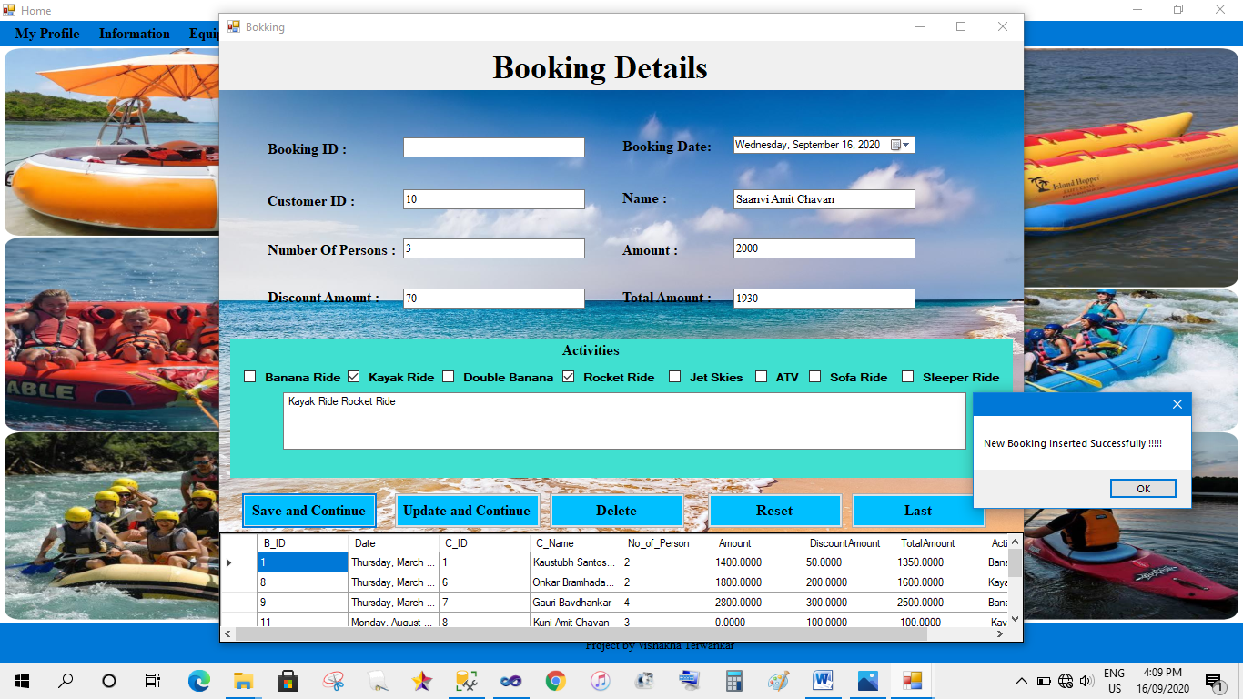

**Code:**

using System;

using System.Collections.Generic;

using System.ComponentModel;

using System.Data;

using System.Drawing;

using System.Linq;

using System.Text;

using System.Windows.Forms;

using System.Data.SqlClient;

using System.Configuration;

namespace WatersportsManagement

{

public partial class Bokking : Form

{

SqlConnection con = new SqlConnection(ConfigurationManager.ConnectionStrings["con"].ToString());

public Bokking()

{

InitializeComponent();

View();

}

public static string c_id;

private void save_Click(object sender, EventArgs e)

{

if (txt1.Text != "")

{

MessageBox.Show("Booking Id already Exist", "validation error", MessageBoxButtons.OK, MessageBoxIcon.Information);

txt1.Focus();

return;

}

else if (dateTimePicker1.Text == "")

{

MessageBox.Show("Date is Required", "validation error", MessageBoxButtons.OK, MessageBoxIcon.Information);

dateTimePicker1.Focus();

return;

}

else if (txt2.Text == "")

{

MessageBox.Show("Cust Id is Required", "validation error", MessageBoxButtons.OK, MessageBoxIcon.Information);

txt2.Focus();

return;

}

else if (txt3.Text == "")

{

MessageBox.Show("Customer Name is Required", "validation error", MessageBoxButtons.OK, MessageBoxIcon.Information);

txt3.Focus();

return;

}

else if (txt4.Text == "")

{

MessageBox.Show("Number of Persons is Required", "validation error", MessageBoxButtons.OK, MessageBoxIcon.Information);

txt4.Focus();

return;

}

/* else if (txt5.Text == "")

{

MessageBox.Show("Amount is Required", "validation error", MessageBoxButtons.OK, MessageBoxIcon.Information);

txt5.Focus();

return;

}*/

else if (txt6.Text == "")

{

MessageBox.Show("discount is Required", "validation error", MessageBoxButtons.OK, MessageBoxIcon.Information);

txt5.Focus();

return;

}

/* else if (txt7.Text == "")

{

MessageBox.Show("Amount is Required", "validation error", MessageBoxButtons.OK, MessageBoxIcon.Information);

txt5.Focus();

return;

}*/

/*else if (listBox1.Text == "")

{

MessageBox.Show("Activity is Required", "validation error", MessageBoxButtons.OK, MessageBoxIcon.Information);

listBox1.Focus();

return;

}*/

else

{

String query = "Insert INTO Booking(Date,C_ID,C_Name,No_of_Person,Amount,DiscountAmount,TotalAmount,Activity)VALUES('" + dateTimePicker1.Text + "','" + txt2.Text + "','" + txt3.Text + "','" + txt4.Text + "','" + txt5.Text + "','" + txt6.Text + "','" + txt7.Text + "','"+listBox1.Text+"')";

SqlCommand cmd = new SqlCommand(query, con);

con.Open();

cmd.ExecuteNonQuery();

con.Close();

MessageBox.Show("New Booking Inserted Successfully !!!!!");

if (txt2.Text == "")

{

MessageBox.Show("Please Select Bill");

}

else

{

c_id = txt2.Text;

Reciept printbill_obj = new Reciept();

printbill_obj.Show();

}

}

View();

}

private void Update_Click(object sender, EventArgs e)

{

if (txt1.Text == "")

{

MessageBox.Show("Select Booking ", "validation error", MessageBoxButtons.OK, MessageBoxIcon.Information);

txt1.Focus();

return;

}

else if (dateTimePicker1.Text == "")

{

MessageBox.Show("Date is Required", "validation error", MessageBoxButtons.OK, MessageBoxIcon.Information);

dateTimePicker1.Focus();

return;

}

else if (txt2.Text == "")

{

MessageBox.Show("Cust Id is Required", "validation error", MessageBoxButtons.OK, MessageBoxIcon.Information);

txt2.Focus();

return;

}

else if (txt3.Text == "")

{

MessageBox.Show("Customer Name is Required", "validation error", MessageBoxButtons.OK, MessageBoxIcon.Information);

txt3.Focus();

return;

}

else if (txt4.Text == "")

{

MessageBox.Show("Number of Persons is Required", "validation error", MessageBoxButtons.OK, MessageBoxIcon.Information);

txt4.Focus();

return;

}

/* else if (txt5.Text == "")

{

MessageBox.Show("Amount is Required", "validation error", MessageBoxButtons.OK, MessageBoxIcon.Information);

txt5.Focus();

return;

}*/

else if (txt6.Text == "")

{

MessageBox.Show("Amount is Required", "validation error", MessageBoxButtons.OK, MessageBoxIcon.Information);

txt5.Focus();

return;

}

else if (listBox1.Text == "")

{

MessageBox.Show("Amount is Required", "validation error", MessageBoxButtons.OK, MessageBoxIcon.Information);

listBox1.Focus();

return;

}

else

{

con.Open();

String query = "update Booking set Date= '" + dateTimePicker1.Text + "',C_ID = '" + txt2.Text + "' ,C_Name='" + txt3.Text + "',No_of_Person='" + txt4.Text + "', Amount = '" + txt5.Text + "', DiscountAmount = '" + txt6.Text + "', TotalAmount = '" + txt7.Text + "' ,Activity='" + listBox1.Text + "' where B_ID = '" + txt1.Text + "' ";

SqlDataAdapter SDA = new SqlDataAdapter(query, con);

SDA.SelectCommand.ExecuteReader();

MessageBox.Show("Booking Updated");

con.Close();

View();

if (txt2.Text == "")

{

MessageBox.Show("Please Select Bill");

}

else

{

c_id = txt2.Text;

Reciept printbill_obj = new Reciept();

printbill_obj.Show();

}

}

}

private void Delete_Click(object sender, EventArgs e)

{

con.Open();

String query = "delete from Booking where B_ID='" + txt1.Text + "'";

SqlDataAdapter SDA = new SqlDataAdapter(query, con);

SDA.SelectCommand.ExecuteReader();

con.Close();

MessageBox.Show("Booking Deleted");

View();

Clear();

}

private void Reset_Click(object sender, EventArgs e)

{

Clear();

}

private void button1_Click(object sender, EventArgs e)

{

con.Open();

String query = "select * from Booking where B_ID = (select max(B_ID) from Booking)";

SqlCommand cmd;

cmd = new SqlCommand(query, con); // Passing Query

SqlDataReader dr;

dr = cmd.ExecuteReader();

if (dr.Read())

{

txt1.Text = dr[0].ToString();

dateTimePicker1.Text = dr[1].ToString();

txt2.Text = dr[2].ToString();

txt3.Text = dr[3].ToString();

txt4.Text = dr[4].ToString();

txt5.Text = dr[5].ToString();

txt6.Text = dr[6].ToString();

txt7.Text = dr[7].ToString();

listBox1.Text = dr[8].ToString();

}

con.Close();

}

private void Clear()

{

txt1.Text = "";

dateTimePicker1.ResetText();

txt2.Clear();

txt3.Clear();

txt4.Clear();

txt5.Clear();

txt6.Clear();

txt7.Clear();

listBox1.ResetText();

checkBox1.Checked = false;

checkBox2.Checked = false;

checkBox3.Checked = false;

checkBox4.Checked = false;

checkBox5.Checked = false;

checkBox6.Checked = false;

checkBox7.Checked = false;

checkBox8.Checked = false;

txt4.ReadOnly = false;

}

public void View()

{

con.Open();

String query = "select * from Booking";

SqlDataAdapter SDA = new SqlDataAdapter(query, con);

DataTable dt = new DataTable();

SDA.Fill(dt);

dataGridView1.DataSource = dt;

con.Close();

}

public int person;

int amt;

int rt1;

int ch1;

int rt2;

int ch2;

int rt3;

int ch3;

int rt4;

int ch4;

int rt5;

int ch5;

int rt6;

int ch6;

int rt7;

int ch7;

int rt8;

int ch8;

private void txt4_TextChanged(object sender, EventArgs e)

{

try

{

person = Convert.ToInt32(txt4.Text);

txt4.ReadOnly=false;

}

catch { }

}

private void txt5_TextChanged(object sender, EventArgs e)

{

try

{

amt = Convert.ToInt32(txt5.Text);

}

catch { }

}

private void checkBox1_CheckedChanged(object sender, EventArgs e)

{

try

{

if (txt4.Text == "")

{

MessageBox.Show("Enter Number Of Persons");

checkBox1.Checked = false;

}

else

{

if (checkBox1.Checked)

{

listBox1.AppendText( checkBox1.Text+"");

con.Open();

String query = "select Rate from Activity where activities = '" + checkBox1.Text + "'";

SqlCommand cmd;

cmd = new SqlCommand(query, con); // Passing Query

SqlDataReader dr;

dr = cmd.ExecuteReader();

while (dr.Read())

{

rt1 = Convert.ToInt32(dr[0]);

ch1 = (rt1 * person);

txt5.Text = Convert.ToString(amt+ch1);

}

con.Close();

}

else

{

listBox1.Text = listBox1.Text.Replace(checkBox1.Text,"");

txt5.Text = Convert.ToString(amt - ch1);

}

}

}

catch { }

}

private void checkBox2_CheckedChanged(object sender, EventArgs e)

{

try

{

if (txt4.Text == "")

{

MessageBox.Show("Enter Number Of Persons");

checkBox2.Checked = false;

}

else

{

if (checkBox2.Checked)

{

listBox1.AppendText(checkBox2.Text + "");

con.Open();

String query = "select Rate from Activity where activities = '" + checkBox2.Text + "'";

SqlCommand cmd;

cmd = new SqlCommand(query, con); // Passing Query

SqlDataReader dr;

dr = cmd.ExecuteReader();

while (dr.Read())

{

rt2 = Convert.ToInt32(dr[0]);

ch2 = (rt2 * person);

txt5.Text = Convert.ToString(amt+ch2);

}

con.Close();

}

else

{

listBox1.Text = listBox1.Text.Replace(checkBox2.Text,"");

txt5.Text = Convert.ToString(amt - ch2);

}

}

}

catch { }

}

private void checkBox3_CheckedChanged(object sender, EventArgs e)

{

try

{

if (txt4.Text == "")

{

MessageBox.Show("Enter Number Of Persons");

checkBox3.Checked = false;

}

else

{

if (checkBox3.Checked)

{

listBox1.AppendText(checkBox3.Text + "");

con.Open();

String query = "select Rate from Activity where activities = '" + checkBox3.Text + "'";

SqlCommand cmd;

cmd = new SqlCommand(query, con); // Passing Query

SqlDataReader dr;

dr = cmd.ExecuteReader();

while (dr.Read())

{

rt3 = Convert.ToInt32(dr[0]);

ch3 = (rt3 * person);

txt5.Text = Convert.ToString(amt + ch3);

}

con.Close();

}

else

{

listBox1.Text=listBox1.Text.Replace(checkBox3.Text,"");

txt5.Text = Convert.ToString(amt - ch3);

}

}

}

catch { }

}

private void checkBox4_CheckedChanged(object sender, EventArgs e)

{

try

{

if (txt4.Text == "")

{

MessageBox.Show("Enter Number Of Persons");

checkBox4.Checked = false;

}

else

{

if (checkBox4.Checked)

{

listBox1.AppendText(checkBox4.Text + "");

con.Open();

String query = "select Rate from Activity where activities = '" + checkBox4.Text + "'";

SqlCommand cmd;

cmd = new SqlCommand(query, con); // Passing Query

SqlDataReader dr;

dr = cmd.ExecuteReader();

while (dr.Read())

{

rt4 = Convert.ToInt32(dr[0]);

ch4 = (rt4 * person);

txt5.Text = Convert.ToString(amt + ch4);

}

con.Close();

}

else

{

listBox1.Text=listBox1.Text.Replace(checkBox4.Text,"");

txt5.Text = Convert.ToString(amt - ch4);

}

}

}

catch { }

}

private void checkBox5_CheckedChanged(object sender, EventArgs e)

{

try

{

if (txt4.Text == "")

{

MessageBox.Show("Enter Number Of Persons");

checkBox5.Checked = false;

}

else

{

if (checkBox5.Checked)

{

listBox1.AppendText(checkBox5.Text + "");

con.Open();

String query = "select Rate from Activity where activities = '" + checkBox5.Text + "'";

SqlCommand cmd;

cmd = new SqlCommand(query, con); // Passing Query

SqlDataReader dr;

dr = cmd.ExecuteReader();

while (dr.Read())

{

rt5 = Convert.ToInt32(dr[0]);

ch5 = (rt5 * person);

txt5.Text = Convert.ToString(amt + ch5);

}

con.Close();

}

else

{

listBox1.Text=listBox1.Text.Replace(checkBox5.Text,"");

txt5.Text = Convert.ToString(amt - ch5);

}

}

}

catch { }

}

private void checkBox6_CheckedChanged(object sender, EventArgs e)

{

try

{

if (txt4.Text == "")

{

MessageBox.Show("Enter Number Of Persons");

checkBox6.Checked = false;

}

else

{

if (checkBox6.Checked)

{

listBox1.AppendText(checkBox6.Text + "");

con.Open();

String query = "select Rate from Activity where activities = '" + checkBox6.Text + "'";

SqlCommand cmd;

cmd = new SqlCommand(query, con); // Passing Query

SqlDataReader dr;

dr = cmd.ExecuteReader();

while (dr.Read())

{

rt6 = Convert.ToInt32(dr[0]);

ch6 = (rt6 * person);

txt5.Text = Convert.ToString(amt + ch6);

}

con.Close();

}

else

{

listBox1.Text=listBox1.Text.Replace(checkBox6.Text,"");

txt5.Text = Convert.ToString(amt - ch6);

}

}

}

catch { }

}

private void checkBox7_CheckedChanged(object sender, EventArgs e)

{

try

{

if (txt4.Text == "")

{

MessageBox.Show("Enter Number Of Persons");

checkBox7.Checked = false;

}

else

{

if (checkBox7.Checked)

{

listBox1.AppendText(checkBox7.Text + "");

con.Open();

String query = "select Rate from Activity where activities = '" + checkBox7.Text + "'";

SqlCommand cmd;

cmd = new SqlCommand(query, con); // Passing Query

SqlDataReader dr;

dr = cmd.ExecuteReader();

while (dr.Read())

{

rt7 = Convert.ToInt32(dr[0]);

ch7 = (rt7 * person);

txt5.Text = Convert.ToString(amt + ch7);

}

con.Close();

}

else

{

listBox1.Text=listBox1.Text.Replace(checkBox7.Text,"");

txt5.Text = Convert.ToString(amt - ch7);

}

}

}

catch { }

}

private void checkBox8_CheckedChanged(object sender, EventArgs e)

{

try

{

if (txt4.Text == "")

{

MessageBox.Show("Enter Number Of Persons");

checkBox8.Checked = false;

}

else

{

if (checkBox8.Checked)

{

listBox1.AppendText(checkBox8.Text + "");

con.Open();

String query = "select Rate from Activity where activities = '" + checkBox8.Text + "'";

SqlCommand cmd;

cmd = new SqlCommand(query, con); // Passing Query

SqlDataReader dr;

dr = cmd.ExecuteReader();

while (dr.Read())

{

rt8 = Convert.ToInt32(dr[0]);

ch8 = (rt8 * person);

txt5.Text = Convert.ToString(amt + ch8);

}

con.Close();

}

else

{

listBox1.Text=listBox1.Text.Replace(checkBox8.Text,"");

txt5.Text = Convert.ToString(amt - ch8);

}

}

}

catch { }

}

private void listBox1_SelectedIndexChanged(object sender, EventArgs e)

{

}

private void txt2_TextChanged(object sender, EventArgs e)

{

try

{

con.Open();

SqlCommand cmd = new SqlCommand("select C_Name from Customer where C_ID = '" + txt2.Text + "'", con);

SqlDataReader dr = cmd.ExecuteReader();

if (dr.Read())

{

txt3.Text = dr[0].ToString();

}

else

{

MessageBox.Show("Not found");

txt2.Text = "";

txt3.Text = "";

}

con.Close();

}

catch { }

}

private void txt6_TextChanged(object sender, EventArgs e)

{

try

{

int disc = Convert.ToInt32(txt6.Text);

txt7.Text = Convert.ToString(amt - disc);

}

catch { }

}

private void dataGridView1_MouseDoubleClick(object sender, MouseEventArgs e)

{

try

{

txt1.Text = dataGridView1.SelectedRows[0].Cells[0].Value.ToString();

dateTimePicker1.Text = dataGridView1.SelectedRows[0].Cells[1].Value.ToString();

txt2.Text = dataGridView1.SelectedRows[0].Cells[2].Value.ToString();

txt3.Text = dataGridView1.SelectedRows[0].Cells[3].Value.ToString();

txt4.Text = dataGridView1.SelectedRows[0].Cells[4].Value.ToString();

txt5.Text = dataGridView1.SelectedRows[0].Cells[5].Value.ToString();

txt6.Text = dataGridView1.SelectedRows[0].Cells[6].Value.ToString();

txt7.Text = dataGridView1.SelectedRows[0].Cells[7].Value.ToString();

listBox1.Text = dataGridView1.SelectedRows[0].Cells[8].Value.ToString();

}

catch { }

}

private void Bokking_Load(object sender, EventArgs e)

{

}

}

}

**Receipt:**

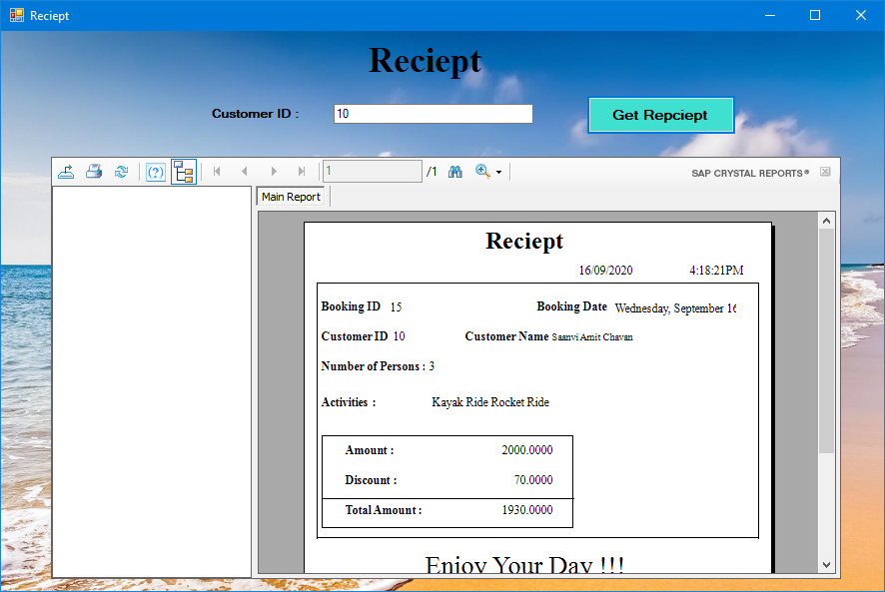

**UNIT TESTING:**

**UNIT TESTING** is a level of software testing where individual units/ components of software are tested. The purpose is to validate that each unit of the software performs as designed. A unit is the smallest testable part of any software. It usually has one or a few inputs and usually a single output. In procedural programming, a unit may be an individual program, function, procedure, etc. In object-oriented programming, the smallest unit is a method, which may belong to a base/ super class, abstract class or derived/ child class. (Some treat a module of an application as a unit. This is to be discouraged as there will probably be many individual units within that module.) Unit testing frameworks, drivers, stubs, and mock/ fake objects are used to assist in unit testing.

**INTEGRATION TESTING:**

**INTEGRATION TESTING** is a level of software testing where individual units are combined and tested as a group. The purpose of this level of testing is to expose faults in the interaction between integrated units. Test drivers and test stubs are used to assist in Integration Testing.

**SYSTEM TESTING:**

**SYSTEM TESTING** is the testing of a complete and fully integrated web product.

System Testing is actually a series of different tests whose sole purpose is to exercise the full web based system.

**NON-FUNCTIONAL TESTING:**

### Performance Testing:

First and foremost type of non-functional testing is performance testing. In order to ensure that the response time of a system is acceptable, performance testing is carried out. By setting up a considerable load and a production-sized database, the system is tested for response times of several business critical processes.

### Load Testing:

Types of non-functional testing in software testing also include load testing. To check whether the system can sustain the pressure or load of many users accessing the system at one time, load testing needs to be carried out. The production load is replicated in the test environment in this case after which the application/system is tested.

### Stress Testing:

This testing is done to pull the system far beyond its capabilities and see how it reacts. Contrary to load testing in which the maximum allowable load is generated, in stress testing, the load generated is more than what the system is expected to handle.

### Security Testing:

While performing non-functional testing, to test how well the system can preserve itself and the data it holds in situation of malicious attacks is called security testing. Confidentiality, integrity, availability, authentication and authorization are the main areas that are tested when security testing is considered. Also, network security, system security and application security are other areas that will be tested in this case.

### Usability Testing:

To verify the ease of usage of an interface within an application is what usability testing is about. Learnability and memorability of the application are main factors in this case. This testing is particularly important when testing GUI.

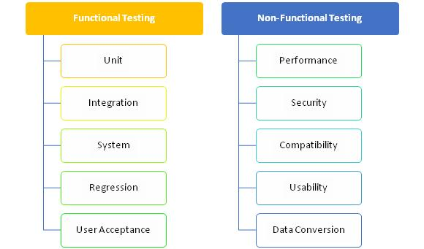

|  |  |  |  |  |  |  |  |
| --- | --- | --- | --- | --- | --- | --- | --- |
|  | **Test Case For Login** | | | | | | |
| **Test Case ID** | **Test Case** | **Test Condition** | **Steps to be executed** | **Expected Result** | **Actual Result** | **Pass/ Fail** | **Comment** |
| TC1 | Click on login of Watersports Management | Enter to the Home page | 1. Click on the Login | Watersports management open for accessing in functionality | As Expected | Pass |  |
| TC2 | User Login | Enter valid User Name & Password | 1.Enter User Name in Textbox  2. Enter Password in password box  3.Click on Login In Button | Admin/Employee logged in. | As Expected | Pass |  |
| TC3 | User Login Test | Enter invalid User Name & Valid Password | 1.Enter invalid User Name in Textbox  2. Enter Password in password box  3.Click on Login In Button | System should display error message: "Please enter valid User Name & Password". | As Expected | Pass |  |
| TC4 | User Login Test | Enter valid User Name & Invalid Password | 1.Enter User Name in Textbox  2. Enter invalid Password in password box  3.Click on Login In Button | System should display error message: "Please enter valid User Name & Password". | As Expected | Pass |  |
| TC5 | User Login Test | Enter invalid User Name & invalid Password | 1.Enter invalid User Name in Textbox  2. Enter invalid Password in password box  3.Click on Login In Button | System should display error message: "Please enter valid User Name & Password". | As Expected | Pass |  |

|  |  |  |  |  |  |  |  |
| --- | --- | --- | --- | --- | --- | --- | --- |
|  | **Test Case For Booking** | | | | | | |
| **Test Case ID** | **Test Case** | **Test Condition** | **Steps to be executed** | **Expected Result** | **Actual Result** | **Pass/ Fail** | **Comment** |
| TC1 | New Booking | Enter to the booking form | 1. Click on the Booking | System opens for accessing in functionality.  1)Booking ID (textbox)  2)Customer ID(textbox)  3)Booking Date(textbox)  4) Name. (textbox)  5)No of Persons(textbox)  6)Amount(textbox)  7)Discount Amount(textbox)  8)Total Amount(textbox)  9)Activities (Checkbox)  10)Save& Continue (Button)  11) Update & Continue (Button)  12) Delete (Button)  13) Reset(Button)  14) Last(Button) | As Expected | Pass |  |
| TC2 | New Booking | Booking of watersports | Enter valid details & Try to Book Activity | System Displays message “New Booking inserted successfully” | As Expected | Pass |  |
| TC3 | New Booking | Invalid Customer ID | Enter invalid Customer ID | System displays message “Not Found” | As Expected | Pass |  |
| TC4 | Booking | Try to access Save & Continue button functionality | Enter valid details Click on the Save & Continue Button | Get Receipt | As Expected | Pass |  |
| TC5 | Booking | Try to access Update & Continue button functionality | 1) Enter valid Customer Id and update details  2) Click on the Update & Continue Button | System displays message “Updated Successfully” | As Expected | Pass |  |
| TC6 | Booking | Try to access Delete button functionality | 1) Enter valid Customer Id  2) Click on the Delete Button | System shows message “/deleted Successfully” | As Expected | Pass |  |
| TC7 | Booking | Try to access Reset button functionality | 1) Enter valid Customer Id  2) Click on the Delete Button | Form shows last inserted information of booking | As Expected | Pass |  |

**CHAPTER-VII**

**RESULTS & DISCUSSION**

**Reports:**

Booking Report:

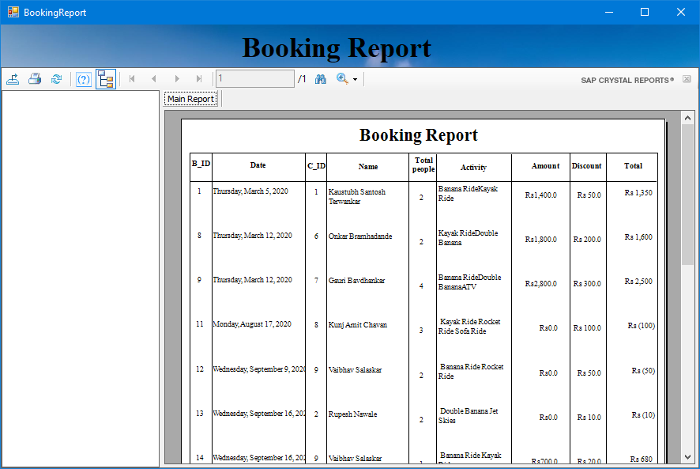

Equipment Report:

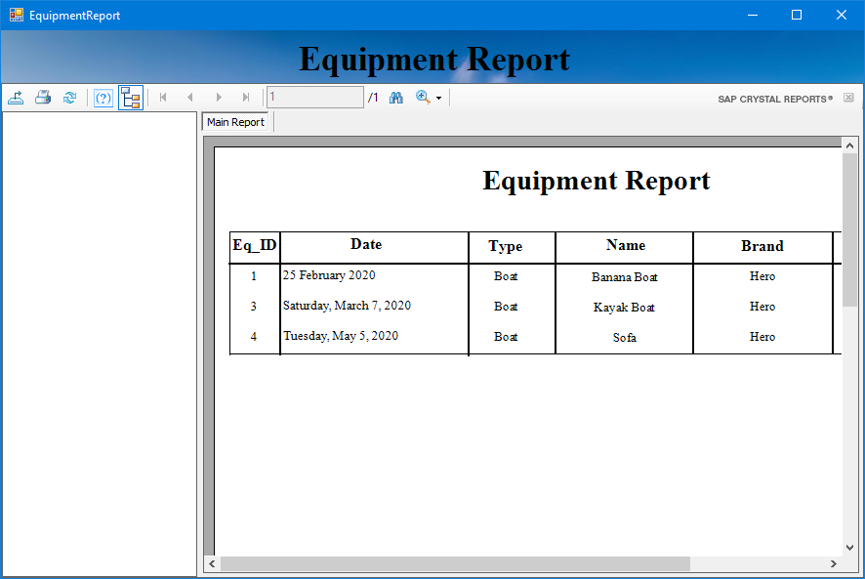

Employee Report:

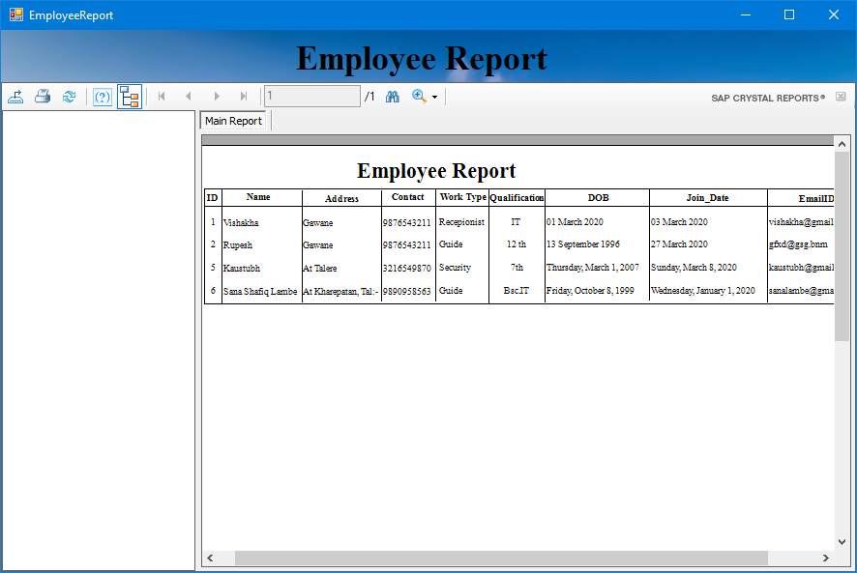

Salary Report:

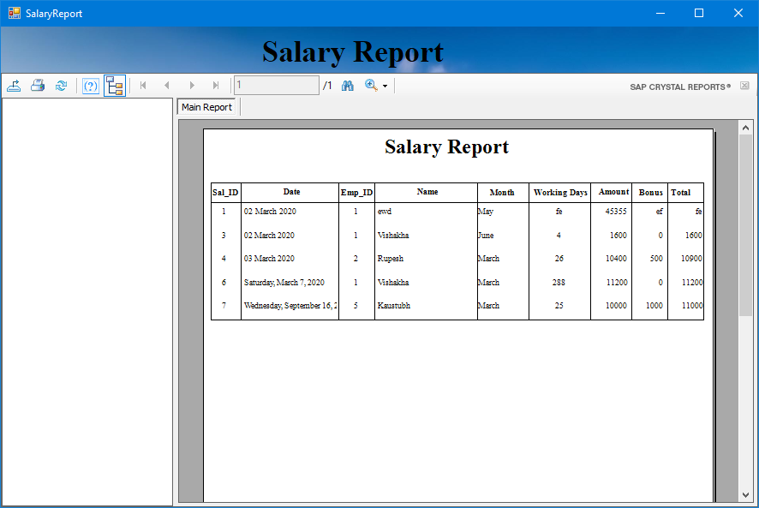

**CHAPTER – VIII**

**CONCLUSION**

**Conclusion**

* This system reduces time and paper work which helps to decreases complication and time.
* The system utilizes for processing of data accurately.
* The Database is design carefully to minimize the redundancy of data.
* The system is design in such a way that further enhancement are ease to implement.
* Watersports Management System helps to reduce time of data processing.

# **Future Enhancement**

* Watersports Management System contain the future enhancement of the project is related to online booking of watersports.
* The rides can add in current watersports.
* Availability of rounds can add.

**REFERENCES & BIBLIOGRAPHY**

1. ASP.NET 4.5 In VS 2010 Professional – Mathew McDonald
2. Mastering VS 2010 – Evangels Petroutsos
3. Murach’s Visual Studio 2010
4. System Analysis And Design – Satzinger Jackson And Burd
5. Software Engineering – Roger Pressman
6. [www.asp.net](http://www.asp.net)
7. [www.google.com](http://www.google.com)
8. [www.youtube.com](http://www.youtube.com)
9. [www.wikipedia.com](http://www.wikipedia.com)
10. [www.w3school.com](http://www.w3school.com)